# Dynamic Quantum Crystallography: Principles, Latest Developments, and Applications

## A. Hoser1, H. Butkiewicz1, A. Ø. Madsen2

### 1Faculty of Chemistry, University of Warsaw, Pasteura 1, 02-093 Warsaw, Poland,

### 2Department of Pharmacy, University of Copenhagen, Universitetsparken 2, Copenhagen, Denmark

### a.hoser@uw.edu.pl

The intensity of the diffracted beam depends on both electron density and thermal motion. While significant progress has been made in electron density modelling (e.g., the Hansen–Coppens multipole model [1], Hirshfeld Atom Refinement (HAR) [2]), the description of thermal motion in crystallography still requires improvement. Anisotropic displacement parameters (ADPs) often do not receive the attention they deserve and are frequently treated as a catch-all for experimental errors—with only a few notable exceptions. ADPs can serve as a valuable source of information about the thermodynamic properties of a given system.

Normal mode refinement (NoMoRe) allows the refinement of vibrational frequencies from DFT calculations against single-crystal X-ray diffraction data [3]. A specific set of scaling factors for normal mode frequencies is refined through the calculation of Debye–Waller factors. This method relies on a direct correlation between the lattice-dynamical model—comprising normal mode vectors and frequencies—and atomic mean-square displacement matrices. The refined frequencies can subsequently be used to estimate thermodynamic properties, such as vibrational contributions to the free energy and heat capacity. Our previous results demonstrated that heat capacities for various compounds (e.g., naphthalene, alanine, and polymorphs of glycine [4, 5]) can be estimated with very good agreement compared to calorimetric data.

In this contribution, I will present the normal mode refinement (NoMoRe) approach, discussing its current developments, applications, (including predictions of heat capacity and estimation of polymorphs' free energies). I will present newest version of NoMoRe (which gives opportunity to model density with aspherical atom model – TAAM or HAR)[6] and a latest version of nomore.chem.uw.edu.pl server. Additionally, as in NoMoRe we are refining much less parameters than in routine refinement, I will present newest applications of NoMoRe to high pressure single crystal data.

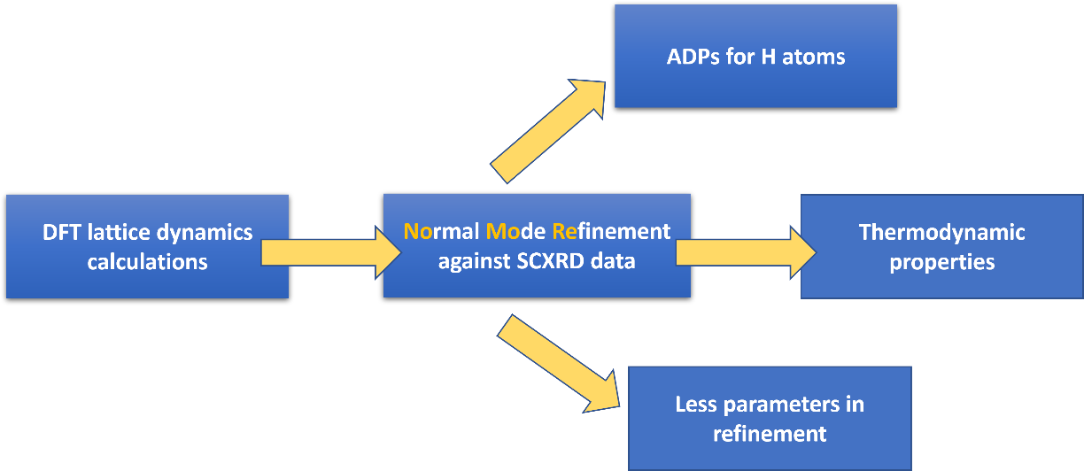

**Figure 1**. Schematic workflow for thermodynamic properties estimation.

#### [1] Hansen N. K., Coppens P., (1978) *Acta Crystallographica Section A,* **34,** 909-921.

#### [2] Capelli S. C., Burgi, H-B., Dittrich B., Grabowsky S., Jayatilaka D., (2014) IUCrJ, 1, 361-379.

#### [3] Hoser A. A., Madsen A. Ø. (2016) *Acta Crystallographica Section A,* **72**, 206-214.

#### [4] Hoser A. A., Madsen A. Ø (2017) *Acta Crystallographica Section A,* **73**, 102-114.

#### [5] Hoser A. A., Sztylko M., Trzybiński D., Madsen A. Ø (2021) *Chemical Communications*, **57**, 9370- 9373.

#### [6] Butkiewicz, H., Chodkiewicz, M., Madsen, A. O. & Hoser, A. A. (2025). IUCrJ, 12, 123-136.

*Financial support from the Polish National Science Centre (SONATA17 grant 2021/43/D/ST4/03136) is kindly acknowledged.*