# X-ray diffuse scattering at high pressures

## B. Wehinger

### European Synchrotron Radiation Facility, 71, avenue des Martyrs, F-38043 Grenoble, France.

### bjorn.wehinger@esrf.fr

X-ray diffuse scattering from single crystals contains valuable information on dynamics and disorder. Thermal vibrations of the atoms, for example, contribute to diffuse scattering in-between Bragg reflections [1] which is usually dominated by acoustic phonons in the vicinity of Bragg reflections. Scattering intensity encode temperature, frequencies and eigenvectors of the phonons and a quantitative analysis in 3D allows to extract the full elasticity tensor to high precision [2]. In the first part of my presentation I will review this method and show how its application to high pressures allows to determine an absolute pressure scale by measuring the crystal structure together with the elastic constants in a single experiment.

In the second part of my presentation I will focus on Quantum Materials in vicinity of phase transitions and show how pressure induced changes of the crystal structure result in peculiar changes of the diffuse scattering. As first example I will present results from the quasi-2D quantum magnet SrCu2(BO3)2 which has strong spin-phonon coupling and which undergoes interesting changes in its phonon dispersion relations upon application of hydrostatic pressure. Thermal diffuse scattering measured at a pressure of 4.5 GPa is shown in Fig. 1. A second example focuses on pressure induced changes of charge order in the kagome superconductor LaRu3Si2 which results in static diffuse scattering at high pressures and low temperatures [3].

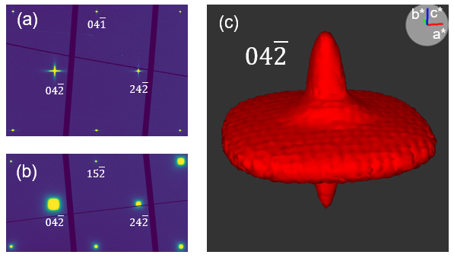

###### **Figure 1**. X-ray diffuse scattering in SrCu2(BO3)2 at a pressure of 4.5 GPa measured at ID27, ESRF using x-rays of 33.17 keV energy. 2D Reciprocal space reconstruction of H4L (a) and HK $\overline{2}$ (b) planes are shown together with a 3D iso-surface representation of the 04 $\overline{2}$ reflection.

#### [1] Bosak, A., Chernyshov, D., Wehinger B., Winkler B., Le Tacon, M. and Krisch, M. (2015). *J. Phys. D: Appl. Phys.* **48**504003*.*

#### [2] Wehinger, B., Mirone, A., Krisch, M. and Bosak A. (2017). *Phys Rev. Lett* **118**, 035502.

#### [3] Ma, K.-Y., Plokhikh, I., Graham, J.N., Mielke III, C., Sazgari, V., Nakamura, H., Islam, S.S., Shin, S., Kral, P., Gerguri, O., Luetkens, H., von Rohr, F.O., Yin, J.-X., Pomjakushina, E., Felser, C., Nakatsuji, S., Wehinger, B., Gawryluk, D.J., Medvedev, S., and Guguchia, Z. (2024) arXiv:2412.05459.