# A Journey into the Complex World of Fampridine Salts

## Riccardo Montis1, Luca Fusaro2, Nikolay Tumanov2

### 1 Università degli Studi di Urbino Carlo Bo, (Italy), 2 University of Namur (Belgium)

### riccardo.montis@uniurb.it

Crystal engineers aim to apply the principles of supramolecular chemistry to design crystalline materials with tailored properties. Complete control over crystallization processes and the ability to predict self-assemblies in solution and solid state are critical to achieving this goal. However, Mother Nature often challenges this ambition, and although extensively investigated, self-assembly in the solid state remains a complex process that sometimes produces surprising results.

Recently, we reported on the complex behaviour of a simple hydrochloride salt of fampridine1,2, an aminopyridine derivative used for the symptomatic treatment of multiple sclerosis. This salt produced unexpectedly complex structures, including Frank-Kasper (FK) phases, previously observed only in metal alloys and soft-matter. These phases crystallised from a precursor dense liquid phase produced by liquid–liquid phase separation. Cryo-electron microscopy revealed spherical aggregates, indicating a complex molecular pre-organization in place before crystallization. In this contribution, we explore the potential reasons for this behaviour and share some of our attempts to isolate similar complex structures for other systems.

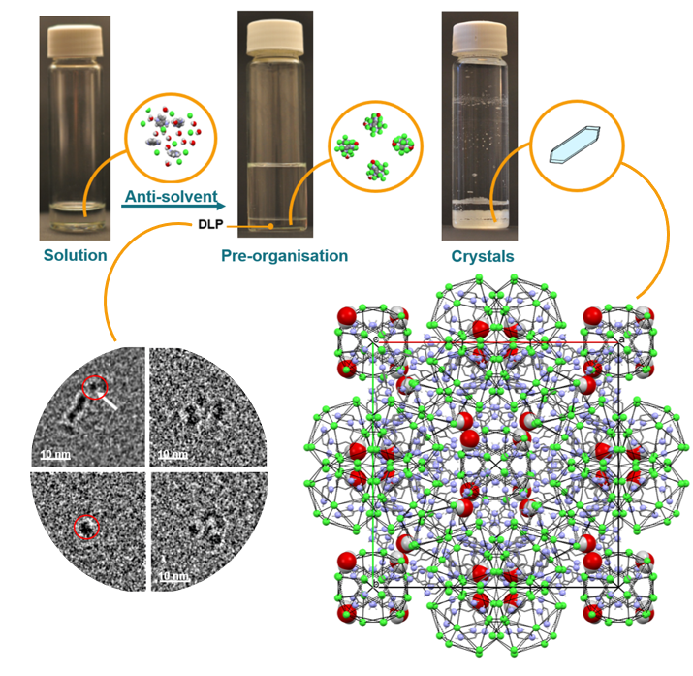

###### **Figure 1**. Example of Frank -Kasper phase for fampridine hydrochloride

#### [1] Montis, R., Fusaro, L., et al. (2021). *Nature.* **590**, 275.

#### [2] Fusaro, L., Tumanov, N. Saielli, G. Montis, R. (2023). *Pure and Applied Chemistry.*, **95**, 1043.