# Tuning the local structure of isoreticular porous materials

## E. G. Meekel*

### 1Institute for Integrated Cell-Material Sciences, Kyoto University, Kyoto 606-8501, Japan.

### Meekel.emily.47t@st.kyoto-u.ac.jp

The concept of isoreticular chemistry has been key in the design of porous framework materials, enabling the tailoring of functionality and pore size whilst preserving the topology [1]. However, subtle variations in the local structure of such isoreticular materials – including the orientation of low-symmetry building blocks, defect distribution, and dynamic disorder – can profoundly influence material properties in ways that are often overlooked [2].

In this talk, I will present a number of case studies on porous materials, including the metal-organic frameworks (MOFs) TRUMOF-1 [3] and UoB-100 [4], which share identical underlying networks yet exhibit distinct local structural deviations. By combining synthetic approaches with X-ray total scattering techniques, such as diffuse scattering and three-dimensional difference pair distribution function (3D-ΔPDF) analysis, I will show how these local variations can be controlled and discuss their impact on chemical properties.

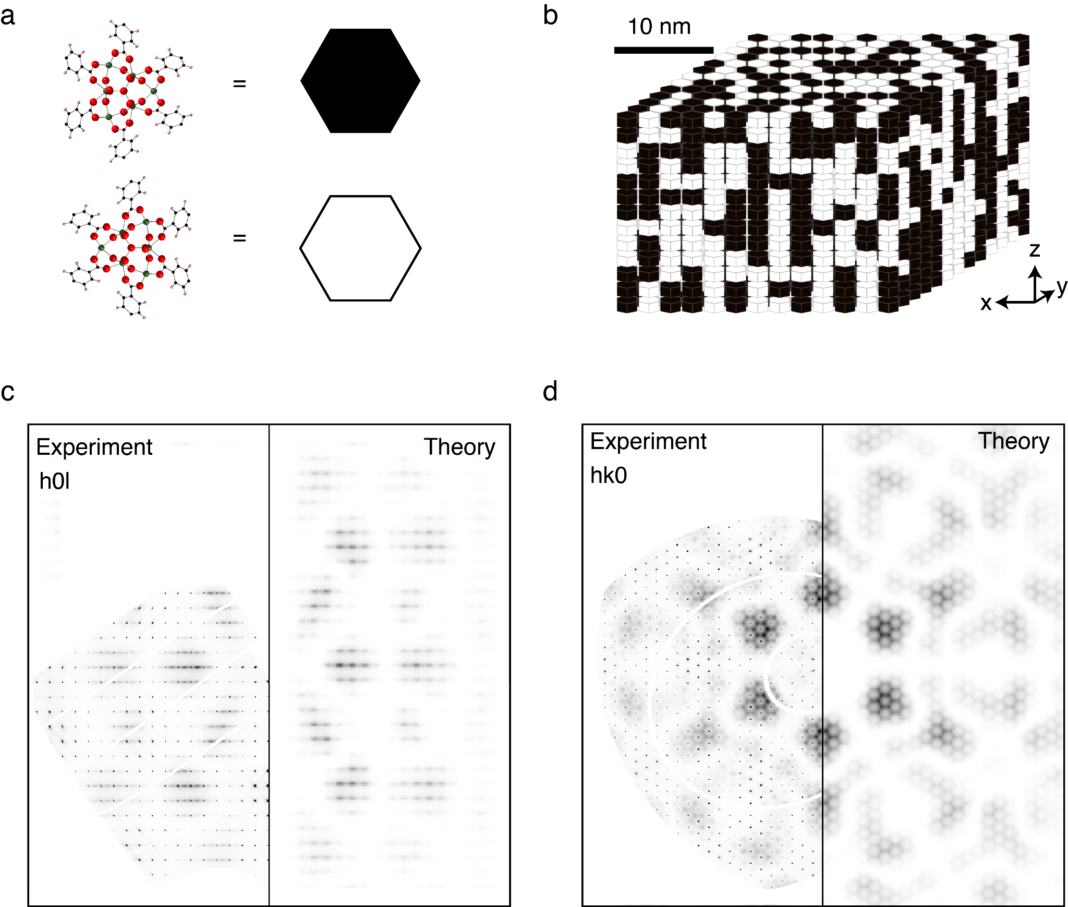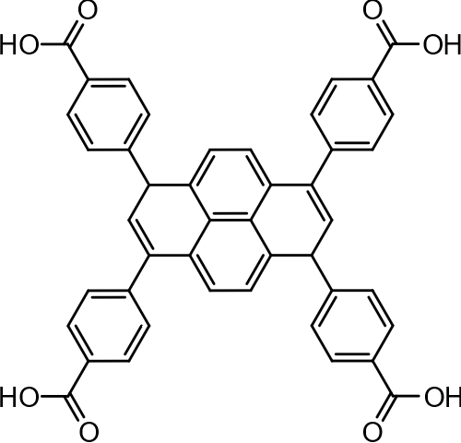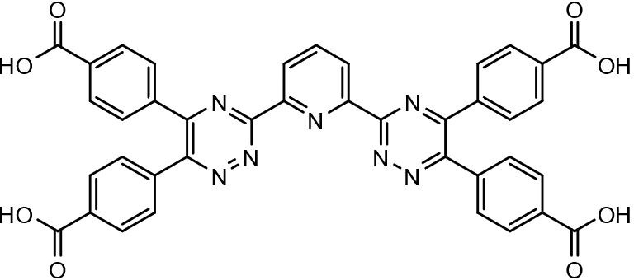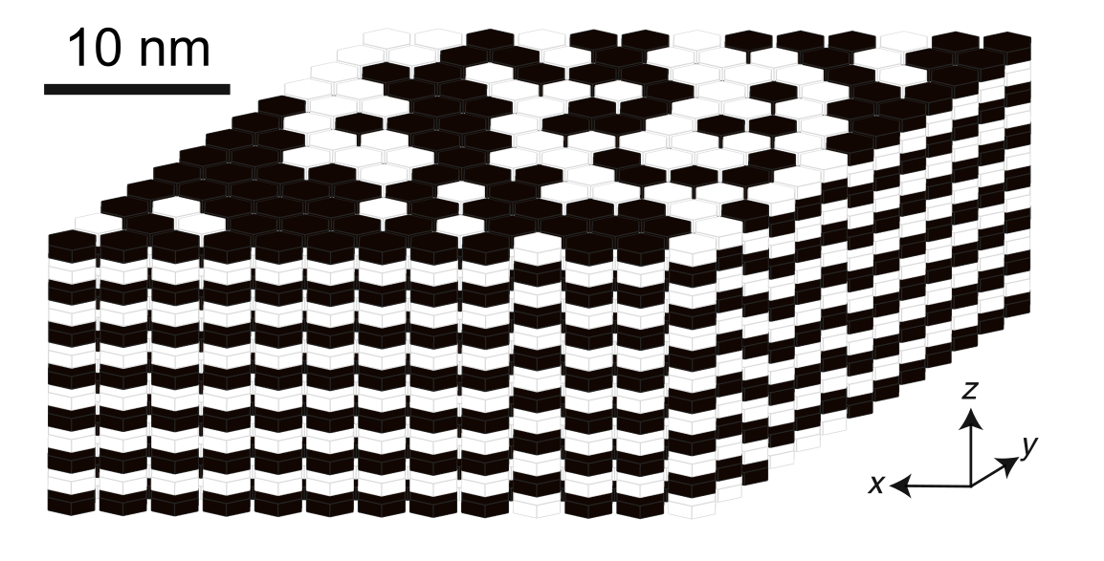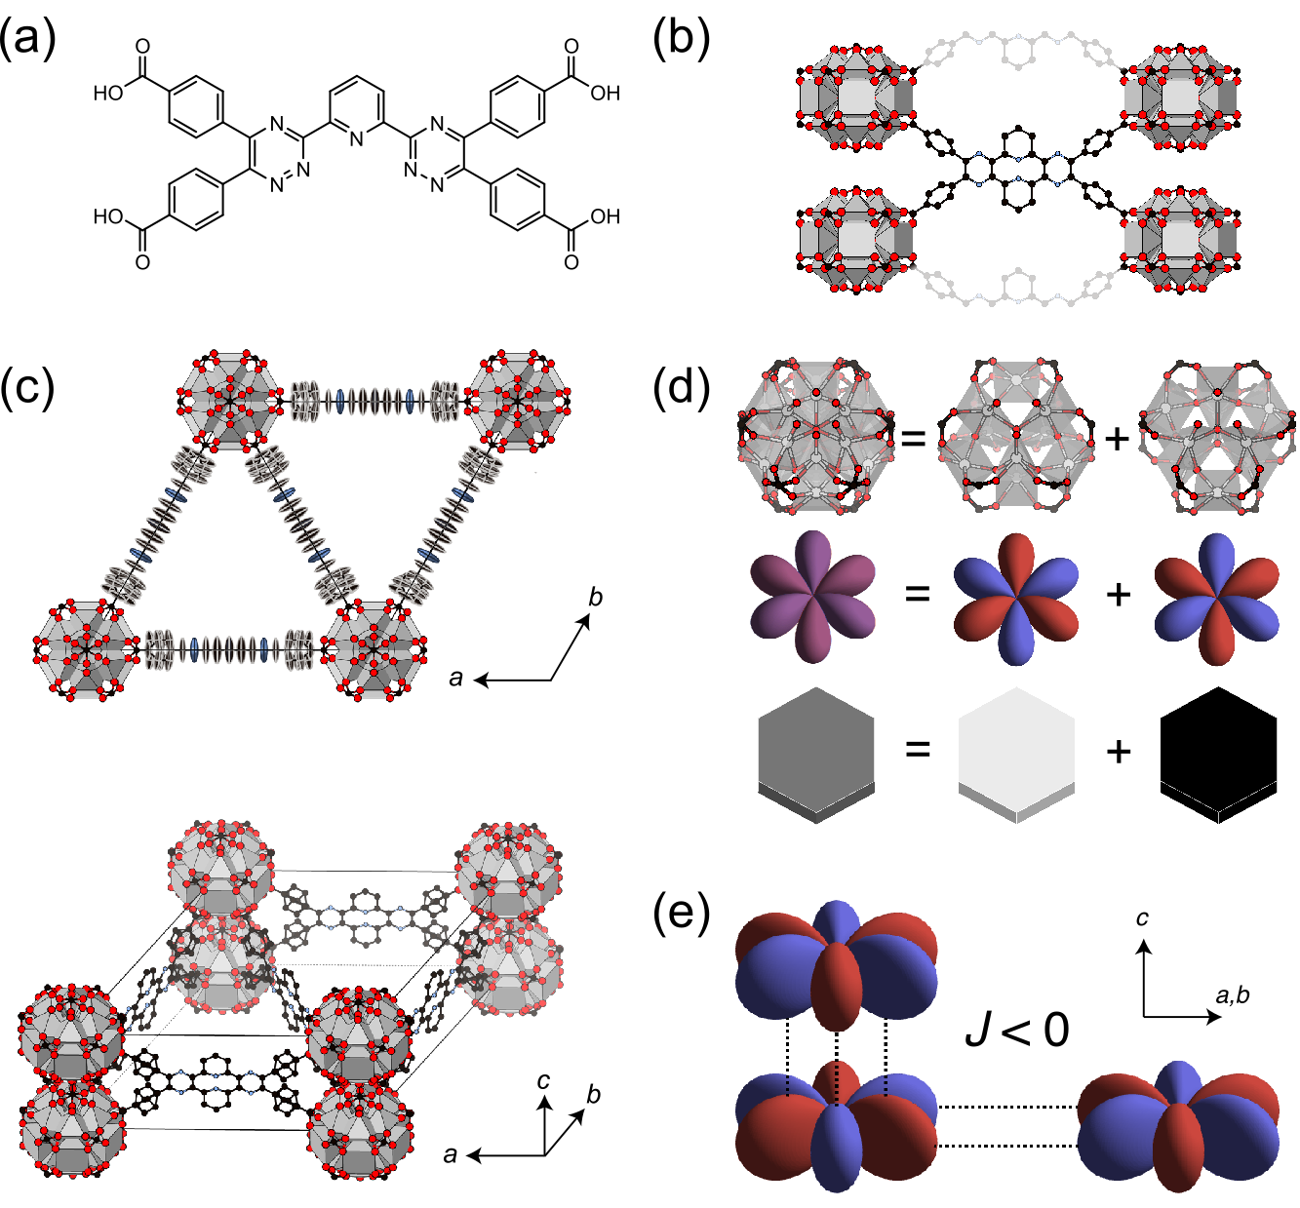

=

=

*hk0*

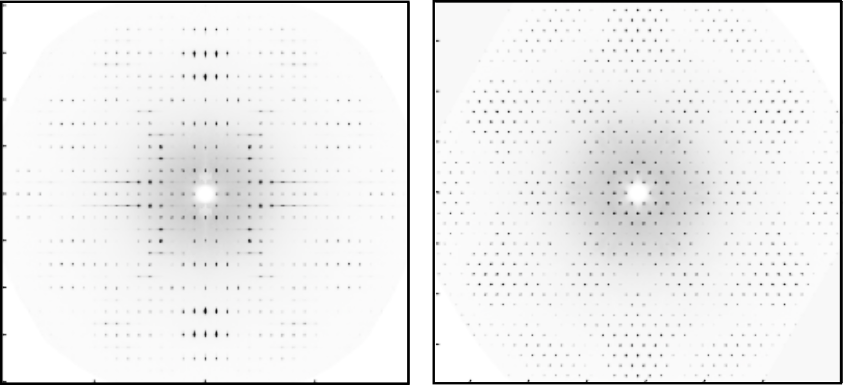

*hk0*

###### **Figure 1**. Schematic illustrating how the linker type influences correlations between two orientations of the metal cluster in UoB-100 (left) and CU-10 (right), leading to distinct diffuse scattering features, in turn indicating the formation of different nanodomains.

#### [1] Yaghi, O., O'Keeffe, M., Ockwig, N. *et al*. Reticular synthesis and the design of new materials. *Nature* **423**, 705–714 (2003)

#### [2] Meekel, E. G. and Goodwin, A. L. Correlated disorder in metal–organic frameworks, *CrystEngComm* **23**, 2915-2922 (2021)

#### [3] Meekel, E. G. *et al.* Truchet-tile structure of a topologically aperiodic metal–organic framework. *Science* **379**, 357-361(2023)

#### [4] Griffin, S.L., Meekel, E.G., Bulled, J.M. *et al*. A lanthanide MOF with nanostructured node disorder. *Nat Commun* **16**, 3209 (2025)