Insights into the community-driven effort behind organizing accessible national crystallography courses by the Polish Young Crystallographers

D. M. Tchoń¹, P. Rejnhardt²

¹Institute of Physics, Czech Academy of Sciences, Prague, Czech Republic, ²Faculty of Chemistry, University of Warsaw, Warsaw, Poland

tchon@fzu.cz
Polish Young Crystallographers (PYC) is an interest group of the Polish Crystallographic Association. Initially launched and formally established at the Polish Crystallographic Meetings of 2022 and 2023, our group supports budding scientists by building relations, representing interests, and promoting the discipline among peers. Since its conception, despite its non-profit character, PYC has realized its goals by organizing a plethora of community events and projects. These include yearly young crystallographer meetings, an e-mail newsletter, an online forum accessible to members and non-members, infographics, and a social media presence. [1]
During our 2023 meeting, the members of PYC made a startling observation. As in any country, members of the Polish crystallographic community have very diverse scientific interests. Individually, they lead the research in their respective fields, exploring seemingly disjoint aspects of the discipline. Unfortunately, we observed that this diversity doesn’t always translate into a collective strength of the community. With the teaching courses naturally reflecting lecturers’ interests, graduates may finish their studies with an inherited lopsided focus on high-pressure mineralogy, charge density analysis, protein engineering, etc. Learning from a single perspective can leave the student biased towards their own field or ill-equipped to discuss others. It can also promote an environment opaque, or even hostile, to a less-initiated community member for whom crystallography is a means rather than a goal itself.
To broaden the perspectives and equalize the chances across students from different institutions, in 2024, we organized a series of open online lectures covering the basics of various fields of the discipline. Rather than attempting to create a complete and unbiased course from scratch, we invited and coordinated a series of meetings with specialists in their respective fields. We strived to find volunteers at different stages of their careers, working at as many universities, technical schools, and companies as possible. The series, held between March and June of 2024, consisted of lectures, workshops, and open discussions. It covered the basics of various aspects of crystallography, from a mathematical introduction to group theory to its application in macromolecular structure determination.

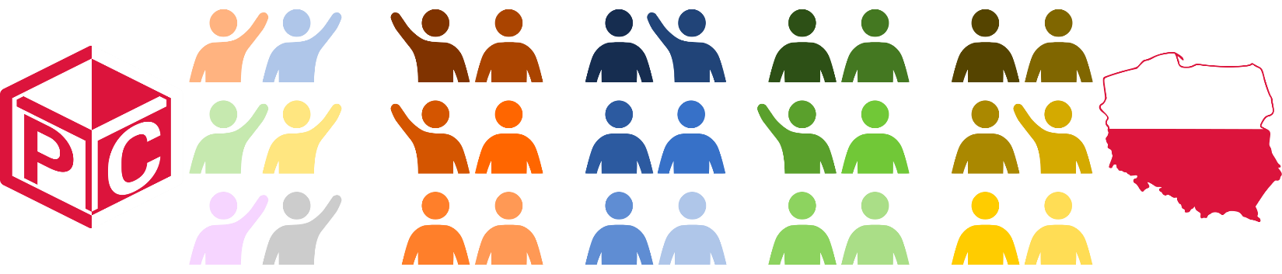

Figure 1. For the 2024 series of our online lectures, the Polish Young Crystallographers invited specialists with various backgrounds and scientific expertise to offer the participants as complete and diverse look onto the discipline as possible.

Here we would like to discuss the most valuable and surprising aspects of the event that may be of use to other groups considering a similar endeavour. We will highlight and honour the supporters and lecturers who, despite a lack of clout or compensation, were willing to adapt their schedules and teaching materials to share their experiences. We will cover online tools and collaborative efforts that enabled us to host an event website, coordinate over 100 participants, and record over 30 hours of meetings with little to no financial cost. We will share our observations and the results of exit reviews, which highlighted the preferences and experiences of the participants. Finally, we hope to promote the next edition of the event planned for early 2026 among potential academic partners, volunteer presenters, and interested participants.

[1] Polish Young Crystallographers (2023). https://www.sekcjamlodychptkryst.pl/.

