Amorphous GeTe: structure vs phase change memory properties

M. Yarema¹

¹Chemistry and Materials Design Group, Institute for Electronics, ETH Zürich Gloriastrasse 35, 8092 Zürich, Switzerland

yaremam@ethz.ch
Phase change memory (PCM) is a non-volatile memory technology, which exploits the rapid and reversible switching capabilities of phase change materials to store information in their physical state. The crystallization and melting phase transitions between the high resistive amorphous state (logical 0) and low resistive crystalline state (logical 1) can be realized in a memory device through electrical or optical pulses, inducing local heating. The reversible phase transitions in phase-change memory devices can switch on the order of nanoseconds, suggesting a close structural resemblance between the amorphous and crystalline phases. Despite this, the link between crystalline and amorphous tellurides is not fully understood nor quantified.
Here we use theoretical calculations and in-situ high-temperature X-ray absorption spectroscopy to quantify the amorphous structure of bulk and nanoscale GeTe. [1] Based on our X-ray experiments, we develop a theoretical model of the amorphous GeTe structure, consisting of sp³-hybridized organic-like Ge chains within a disordered fcc-type Te sublattice (Fig. 1). Strikingly, our intuitive and scalable model provides an accurate description of the structural dynamics in phase-change memory materials, observed experimentally. Specifically, we present a detailed crystallization mechanism through the formation of an intermediate, partially stable ‘ideal glass’ state and demonstrate differences between bulk and nanoscale GeTe leading to size-dependent crystallization temperature. [2]

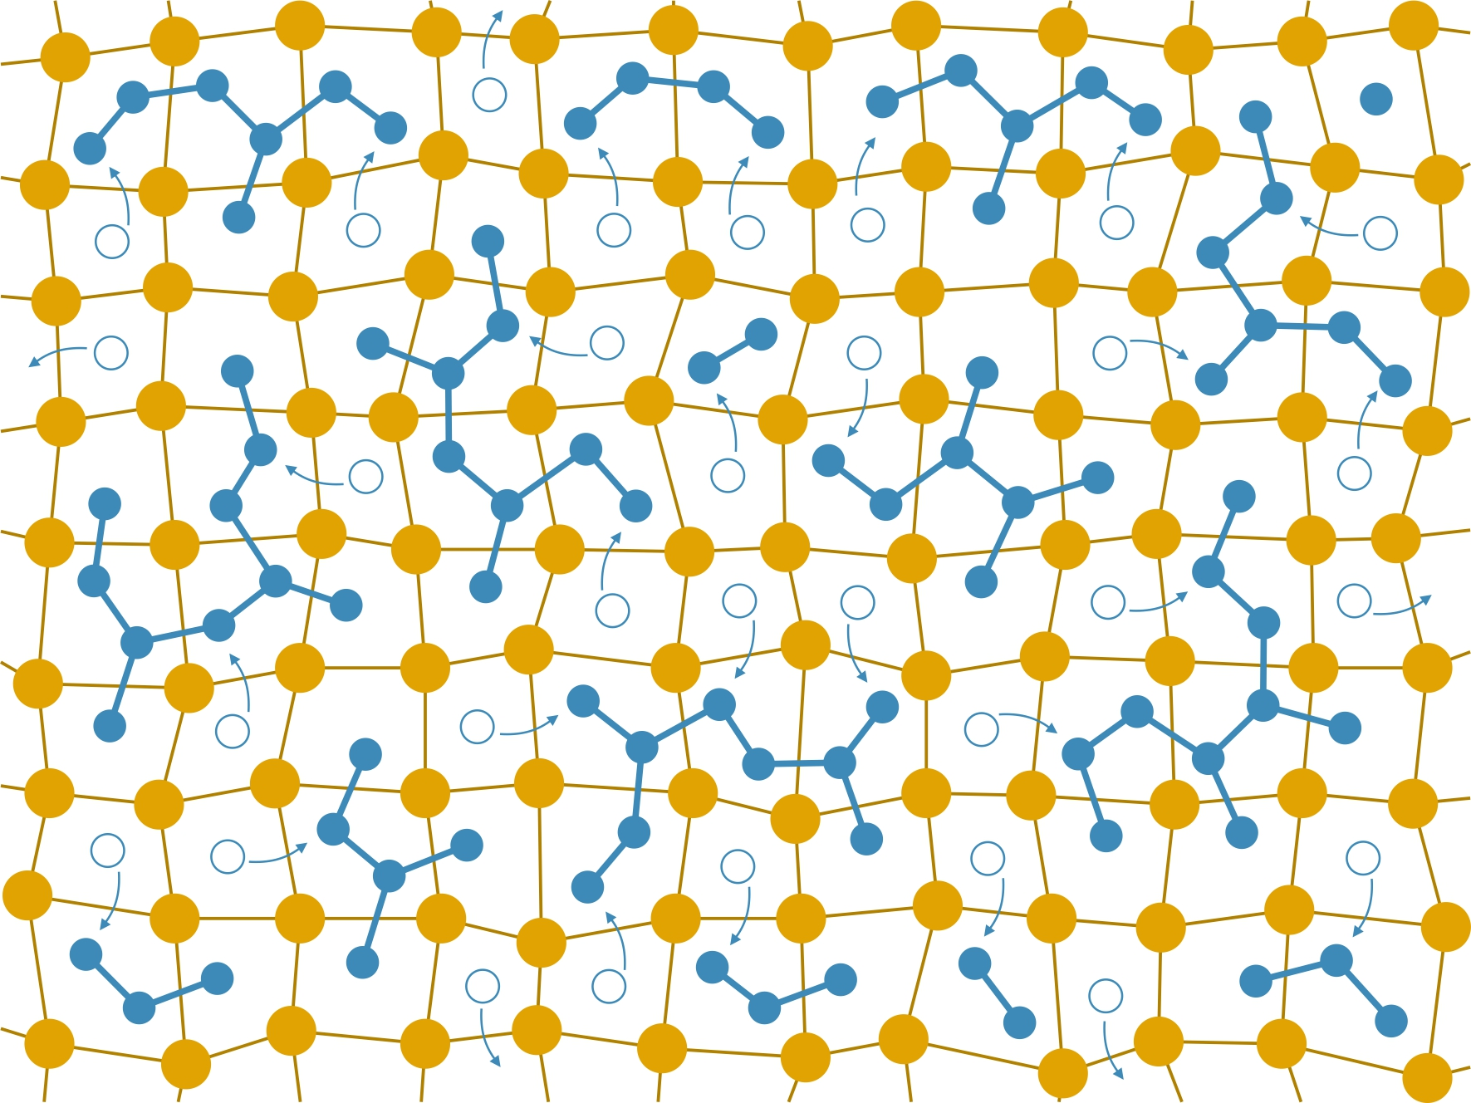

Figure 1. 2D depiction of the GeTe amorphous model to illustrate the amorphization process.

[1] Wintersteller, S., Yarema, O., Kumaar, D., Schenk, F. M., Safonova, O., Abdala, P. M., Wood, V. & Yarema, M. (2024). Nature Commun. 15, 1011.

[2] Yarema, O., Perevedentsev, A., Ovuka, V., Baade, P., Volk, S., Wood, V. & Yarema, M. (2018). Chem. Mater. 30, 6134.

