# Structure of a DNA-Stabilized Ag16Cl2 Nanocluster in Solution

## A. F. Sapnik1, G. Romolini1, C. Cerretani1, T. Vosch1, K. M. Ø. Jensen1

### 1Department of Chemistry, University of Copenhagen, Denmark

### afs@chem.ku.dk

We demonstrate the power of synchrotron X-ray total scattering and pair distribution function (PDF) analysis to resolve the first solution-state structure of a complex, dynamic, nanoscale system: a DNA-stabilised silver nanocluster (DNA-AgNC).[1] These nanoclusters exhibit tuneable photophysical properties, making them attractive for sensing, imaging, and quantum applications, yet their atomic structures remain largely unknown.[2] While a handful of DNA-AgNCs have been characterised by single-crystal X-ray diffraction, the vast majority have been inaccessible in crystalline form. Here, we isolate atomic correlations from an 18-atom Ag16Cl2 core embedded within a highly disordered DNA matrix in solution. PDF refinement reveals displacive and rotational distortions relative to the known crystalline form, alongside new insights into the conformational dynamics of the DNA scaffold.[3] We develop a new statistical ensemble refinement approach—drawing inspiration from reverse Monte Carlo methods—to quantify structural heterogeneity and assess model uniqueness. This work showcases how modern synchrotron PDF methods can resolve sub-nanometre structural differences in complex, solvated nanoclusters at low concentrations, allowing for *in situ* structure–function studies across soft matter, biomolecular, and cluster chemistry domains.

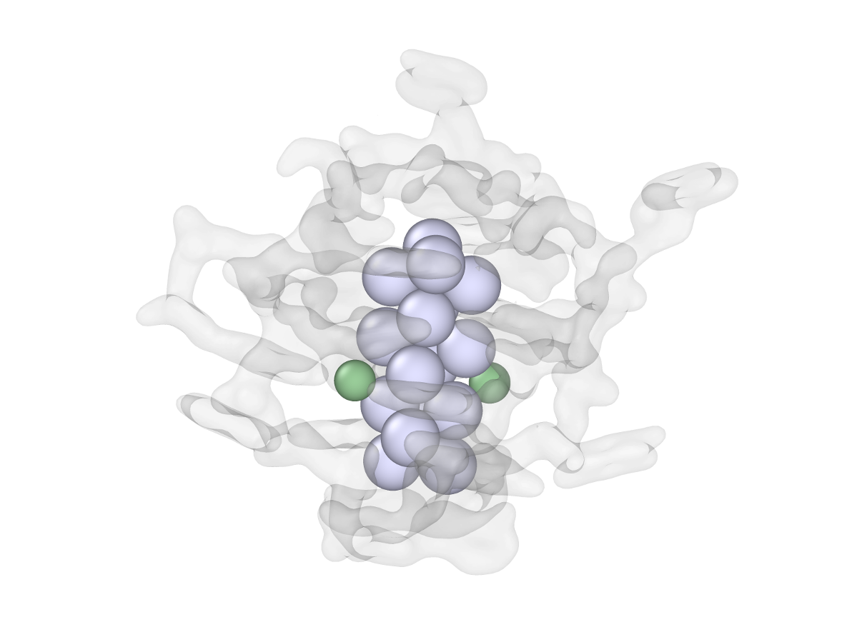

###### **Figure 1**. Atomistic structure of DNA2-[Ag16Cl2]8+.

#### [1] A. F. Sapnik *et al.*, *Angew. Chem. Int. Ed.*, e202422432 (2025).

#### [2] A. Gonzàlez-Rosell *et al.*, *Nanoscale Adv.*, **3**, 1230-1260 (2021).

#### [3] C. Cerretani *et al.*, *Angew. Chem. Int. Ed.*, **58**, 17153 –17157 (2019).