## Spatial and Temporal Visualization of Polymorphic Transformations in Pharmaceutical Tablets

## Julia Gasol-Cardona,1,2 Dr. Martin R. Ward,1,2 Olof Gutowski,3 Dr. Jakub Drnec,4 Dr. Christian Jandl,5 Dr. Danny Stam,5 Dr. Andrew G. P. Maloney,6 Prof. Daniel Markl,1,2 Dr. Stephen W. T. Price,7 Dr. Iain D. H. Oswald1

### 1Strathclyde Institute of Pharmacy and Biomedical Sciences, University of Strathclyde, 161 Cathedral Street, Glasgow, G4 0RE,United Kingdom, 2Centre for Continuous Manufacturing and Advanced Crystallisation(CMAC), University of Strathclyde, 99 George Street, Glasgow, G1 1RD, United Kingdom, 3Deutsches Elektronen-Synchrotron DESY, Notkestraße 85, 22607 Hamburg, Germany, 4European Synchrotron Radiation Facility, 71 Avenue des Martyrs, 38000 Grenoble, France, 5ELDICO Scientific AG,Switzerland Innovation Park Basel Area, Hegenheimermattweg 167 A, 4123 Allschwil, Switzerland, 6The Cambridge Crystallographic Data Centre, 12 Union Road,Cambridge, CB2 1EZ, United Kingdom, 7Finden Limited, Merchant House, 5 East St Helens Street, Abingdon, OX14 5EG, United Kingdom

### Iain.oswald@strath.ac.uk

In this talk, we present the application of X-ray Diffraction Computed Tomography (XRD-CT) to pharmaceutically relevant tablets subjected to varying compression pressures (Figure 1) — conditions known to influence intermolecular interactions and crystal packing. By incorporating the pressure-sensitive marker glycolide,[1,2] we were able to spatially resolve pressure-induced transformations within intact tablets, avoiding artifacts from sample preparation.[3] A follow-up study conducted one month later revealed an in-situ hydrolysis reaction of glycolide, highlighting the dynamic nature of the solid-state environment. The structure of the hydrolysis product was further elucidated using complementary electron diffraction techniques. These findings demonstrate the utility of XRD-CT for uncovering pressure- and time-dependent changes in molecular crystals, with implications for understanding non-covalent interaction networks and their role in the stability and evolution of pharmaceutical formulations.

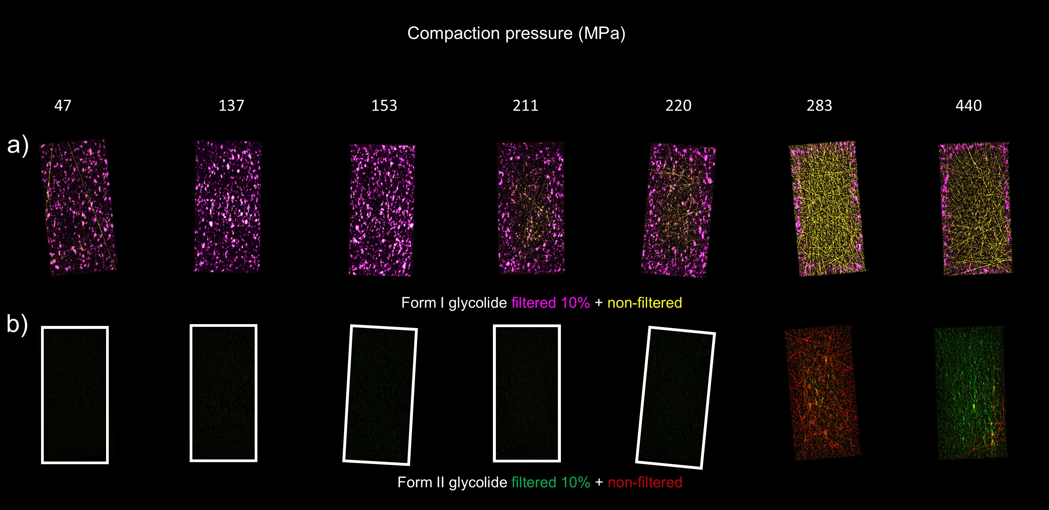

###### **Figure 1**. The XRD-CT images of tablets compressed to different compaction pressure indicating change in the polymorphism at higher compaction pressures.[3]

[1] Hutchison, I. B.; Delori, A.; Wang, X.; Kamenev, K. V.; Urquhart, A. J.; Oswald, I. D. H. *CrystEngComm* **2015**, *17* (8), 1778–1782. https://doi.org/10.1039/C5CE00119F.

[2] Hutchison, I. B.; Bull, C. L.; Marshall, W. G.; Parsons, S.; Urquhart, A. J.; Oswald, I. D. H. *Acta Crystallographica Section B: Structural Science, Crystal Engineering and Materials* **2017**, *73* (6), 1151–1157. https://doi.org/10.1107/S2052520617015657.

[3] Gasol-Cardona, J.; Ward, M. R.; Gutowski, O.; Drnec, J.; Jandl, C.; Stam, D.; Maloney, A. G. P.; Markl, D.; Price, S. W. T.; Oswald, I. D. H. *Angewandte Chemie International Edition* **2025**, *64* (2), e202412976. https://doi.org/10.1002/anie.202412976.