# Relating structure and spin crossover properties in Hofmann complexes

## M. G. Robb1,2, H. L. B. Boström1,2

### 1Department of Chemistry, Stockholm University, Svante Arrhenius väg 16C, SE-106 91 Stockholm, Sweden, 2Wallenberg Initiative Materials Science for Sustainability, Department of Chemistry, Stockholm University, SE-114 18 Stockholm, Sweden

### hanna.bostrom@su.se

Spin crossover (SCO)—reversible switching between the high and low spin states (HS/LS) of a transition metal—is a fascinating phenomenon often observed in compounds with N-coordinated octahedral Fe2+ ions. Most commonly, the switching is induced by thermal changes and is characterized by the transition temperature *T*1/2, but spin crossover can also be stimulated bypressure, radiation, or guest adsorption [1,2]. The strong coupling between spin state and optical/magnetic properties allows for many applications within sensing, memory storage, and solid-state calorics [2,3]. In general, the SCO behaviour is extremely sensitive to chemical/structural changes—even isotopic labelling can change the *T*1/2 and hysteresis [4]. While this theoretically increases the scope for property optimisation, the extreme sensitivity also complicates the development of structure–property relationships.

One of the most well-studied families within the SCO field is the Hofmann complexes: FeL*x*M(CN)4 (L = organic ligand, *x* = 1–2, M = Ni/Pt/Pd), on account of their tunability and strong cooperativity. Structurally, they consist of inorganic metal–cyanide layers joined by organic linkers (L), linked either covalently or by supramolecular interactions [Fig. 1(a)]. The crystal structure is flexible and a range of distortions of the linker and the inorganic layers are possible. This, together with the many available linkers, leads to very diverse SCO behaviour and crystal structures.

This contribution presents a metastudy of the structures and SCO properties of over 300 Hofmann complexes from literature, thereby identifying structural and compositional factors conducive to good spin crossover properties [5]. In terms of the former, group-theoretical decomposition of the crystal structures allows the structural distortions to be categorized and related to the SCO behaviour [6]. While a wealth of rigid-body distortions is available to the family of Hofmann complexes, a relatively small subset is experimentally observed. In general, systems without symmetry-lowering distortions can show higher *T*1/2, than heavily distorted structures. Looking at compositional factors, it appears *e.g*. that compounds with M = Ni are less likely to show spin crossover, relative to if M = Pd or Pt [Fig. 1(b)]. Our study advances the understanding of structure-property relationships in this critical class of spin crossover materials.

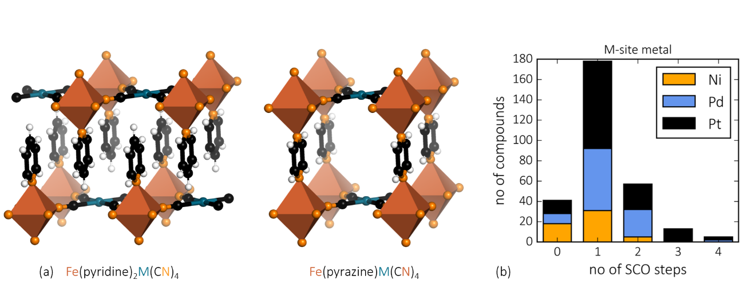

###### **Figure 1**. (a) Representative structures of two different Hofmann complexes. (b) The distribution of Hofmann complexes with spin crossover transitions with 0-4 steps (0 steps indicates no spin crossover) coloured by the M-site cation.

#### [1] Gütlich, P., Garcia, Y. & Goodwin, H. A. (2000). *Chem. Soc. Rev.,* **29**, 419.

#### [2] Kucheriv, O. I., Fritsky, I. O. & Gural’skiy, I. A. (2021). *Inorg. Chim. Acta*, **521**, 120303.

[3] Seredyuk, M. *et al*. (2024). *Adv. Funct. Mater*., 2315487

[4] Hosoya, K. *et al*. (2003). *Phys. Chem. Chem. Phys*., **5**, 1682.

#### [5] Robb, M. G. & Boström, H. L. B. (2025). *submitted*

#### [6] Campbell, B. J., Stokes, H. T., Tanner, D. E. & Hatch, D. M. (2006). *J. Appl. Cryst*., **39**, 607.