# Covalent Fragment-Based Drug Discovery as a Strategy to Combat Leishmaniasis.

## Maria Cristina Nonato1

### 1 Center for the Research and Advancement in Fragments and molecular Targets (CRAFT), School of Pharmaceutical Sciences at Ribeirao Preto, University of São Paulo, Ribeirão Preto 14040-903, SP, Brazil

### cristy@fcfrp.usp.br

### Covalent inhibition has emerged as a powerful strategy in drug discovery, offering a unique combination of potency, selectivity, and sustained target engagement. Building on our previous findings—where we identified barbituric acid derivatives as orotate bioisosteres that, upon introduction of an exocyclic double bond, acted as covalent inhibitors of Leishmania braziliensis dihydroorotate dehydrogenase (LbDHODH)—we now report a new series of conjugated diene–barbituric acid compounds derived from the most potent previously identified inhibitor, 2i, a nanomolar compound with antiparasitic activity.

### This new series was rationally designed to explore how steric and electronic modifications impact both enzymatic inhibition and covalent reactivity. As anticipated, the compounds maintained a time-dependent inhibition profile. Notably, the most potent analogue, QHM1109 (IC₅₀ = 47 ± 2 nM), exhibited a tenfold improvement in potency compared to 2i. Regarding reactivity, the para-fluorinated derivative QHM1151 showed the highest Kinact/Ki value (1270 ± 40 s⁻¹ M⁻¹), doubling the efficiency observed for 2i.

### X-ray crystallography of LbDHODH in complex with the two most active compounds confirmed covalent bond formation via 1,6-Michael addition between the conjugated diene and the catalytic cysteine (Fig.1). This covalent modification led to an overall reorganization of the enzyme's active site: Cys131 was repositioned, Met70 and Leu72 underwent local rearrangements, and the side chain of Phe100 was rotated—altogether enhancing complex stability.

### These results further validate LbDHODH as a promising target for leishmaniasis treatment and offer valuable insights into the stereoelectronic principles that govern covalent reactivity. This work paves the way for the rational development of next-generation covalent inhibitors targeting parasitic neglected tropical diseases (NTDs).

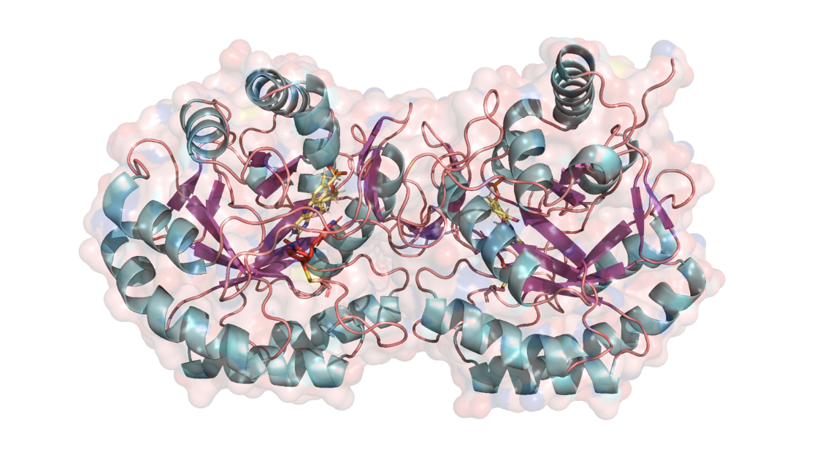

###### **Figure 1**. **Overall structure of *Lb*DHODH in complex with QHM1082.** Surface (transparent) and cartoon representation highlighting the conserved α/β-barrel fold characteristic of Class 1A DHODHs, composed of eight parallel β-strands (β1–β8, purple) surrounded by eight α-helices (α1–α8, cyan), and two short antiparallel strands (βA and βB, copper) stabilizing the barrel base. The FMN cofactor (yellow sticks) and QHM1089 ligand (orange sticks) are positioned at the active site located at the top of the barrel.

#### [4] Reis, R. A. G.; Lorenzato Jr., E.; Silva, V. C.; Nonato, M. C. *Acta Crystallographica Section F: Structural Biology Communications*, v. 71, n. 5, p. 547–552, 2015

*We thank the staff of the MANACÁ beamline at the Sirius synchrotron (LNLS/CNPEM, Brazil) for their invaluable support during data collection. We also gratefully acknowledge financial support from the National Institutes of Health (NIH), which made this work possible.*