Time-resolved X-ray diffraction studies of enzymatic reactions

Richard Neutze

¹Department of Chemistry and Molecular Biology, University of Gothenburg

Email of communicating: richard.neutze@gu.se
Time-resolved X-ray crystallography allows time-dependent structural changes to be visualized at atomic-resolution as they evolve within protein crystals over a time-domain from sub-picoseconds to seconds [1]. Serial crystallography [2] is now routinely used for time-resolved X-ray diffraction studies of macromolecules at X-ray free electron laser and synchrotron radiation facilities. As the field grows, biological reactions that are not naturally light sensitive will be increasingly studied using time-resolved serial crystallography. In this presentation I will outline the development of time-resolved X-ray crystallography and in particular the growth of the field since the first proof-of-principle demonstration of time-resolved serial femtosecond X-ray crystallography [3]. Structural results from the light-driven proton pump bacteriorhodopsin [4] will be used to illustrate what is possible with these methods as well as discussing some controversies in the field [5].

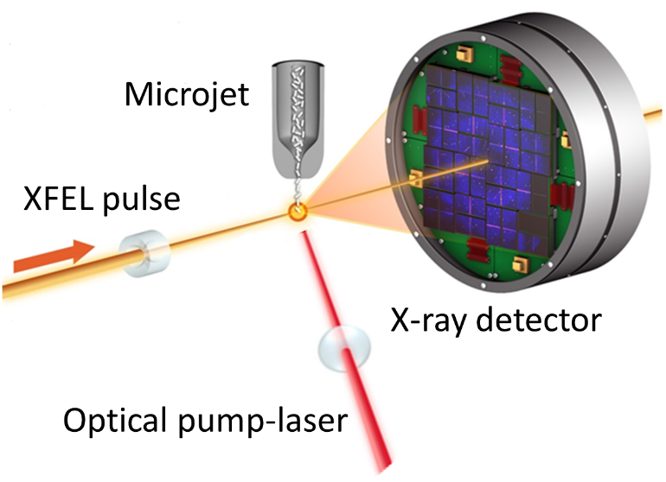

Figure 1. Schematic of a pump-probe time-resolved serial X-ray crystallography setup used at an X-ray free electron laser. Schematic taken from Reference [1].

[1] Branden, G. & Neutze, R. (2021). Science 373, eaba0954; Khusainov, G., Standfuss, J. & Weinert, T. (2024). Struct Dyn 11, 020901.
[2] Chapman, H. N., et al. (2011). Nature 470, 73-77.
[3] Tenboer, J., et al. (2014). Science 346, 1242-1246.
[4] Nango, E., et al. (2016). Science 354, 1552-1557; Nogly, P. et al. (2018). Science 361, eaat0094; Bertrand, Q. et al. (2024). Nat Commun 15, 10278.
[5] Barends, T. R. et al. (2024). Nature 626, 905-911; Neutze, R. & Miller, R. J. D. (2024). Nature 626, 720-722.

