# Detecting Symmetry Groups in Crystallographic Tilings

## B. Naskrecki1, P. Balewski2, M. Janicki2, J. Kubiak2, J. Lorenz2, J. Malinowski3, D. Brzeziński2

### 1Adam Mickiewicz University Poznań 2Poznań University of Technology 3Wrocław University of Technology

### bartosz.naskrecki@amu.edu.pl

In crystallography, identifying symmetry groups is crucial for understanding material properties and structures. Our research combines mathematical theory with machine learning to automate the detection of symmetry groups in crystallographic tilings, cf. [3-5].

By analyzing growth function coefficients derived from orphic diagrams [1], we develop a hierarchical classification approach that precisely identifies the 17 wallpaper groups in two-dimensional space. This interdisciplinary approach bridges pure mathematics with practical applications in crystallography and material science.

Crystallographic groups characterize the symmetry of periodic patterns in nature. The classification of these groups is well-established mathematically, but identifying them from physical data remains challenging. In two dimensions, 17 distinct wallpaper groups exist, each with unique combinations of translations, rotations, reflections, and glide reflections. Our work develops an AI-driven approach to classify these groups based on their growth characteristics rather than conventional geometric analysis.

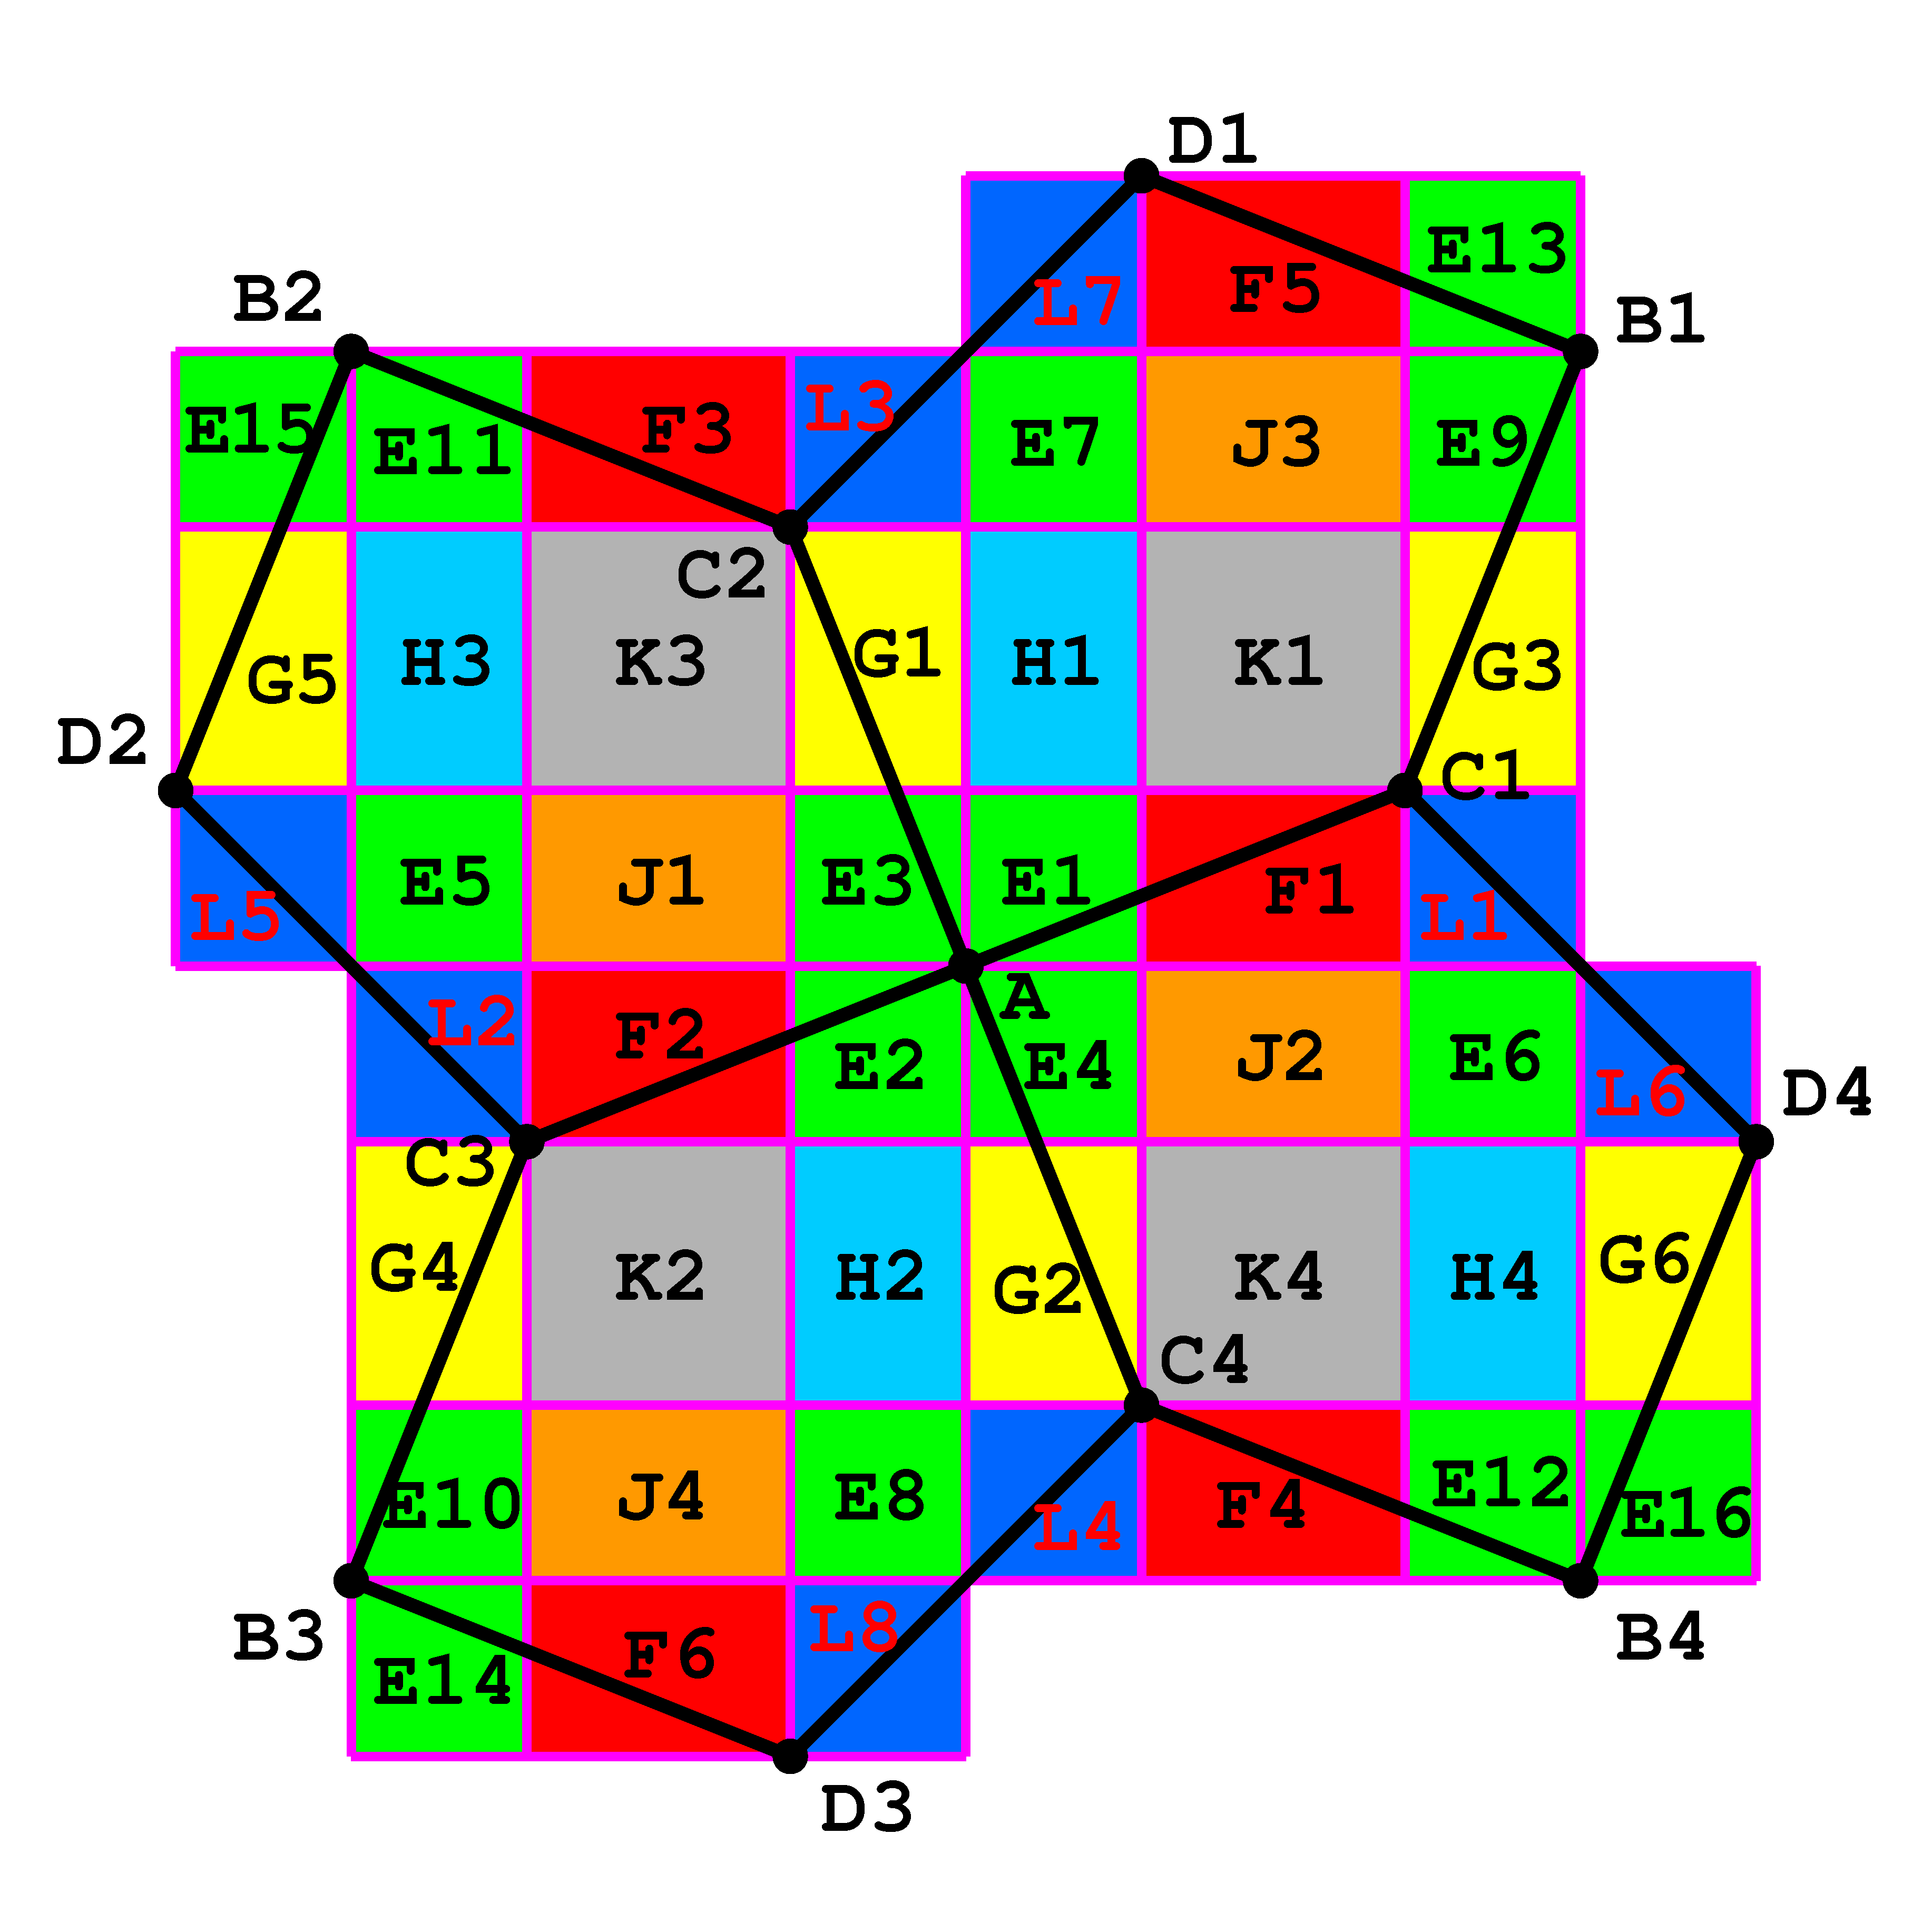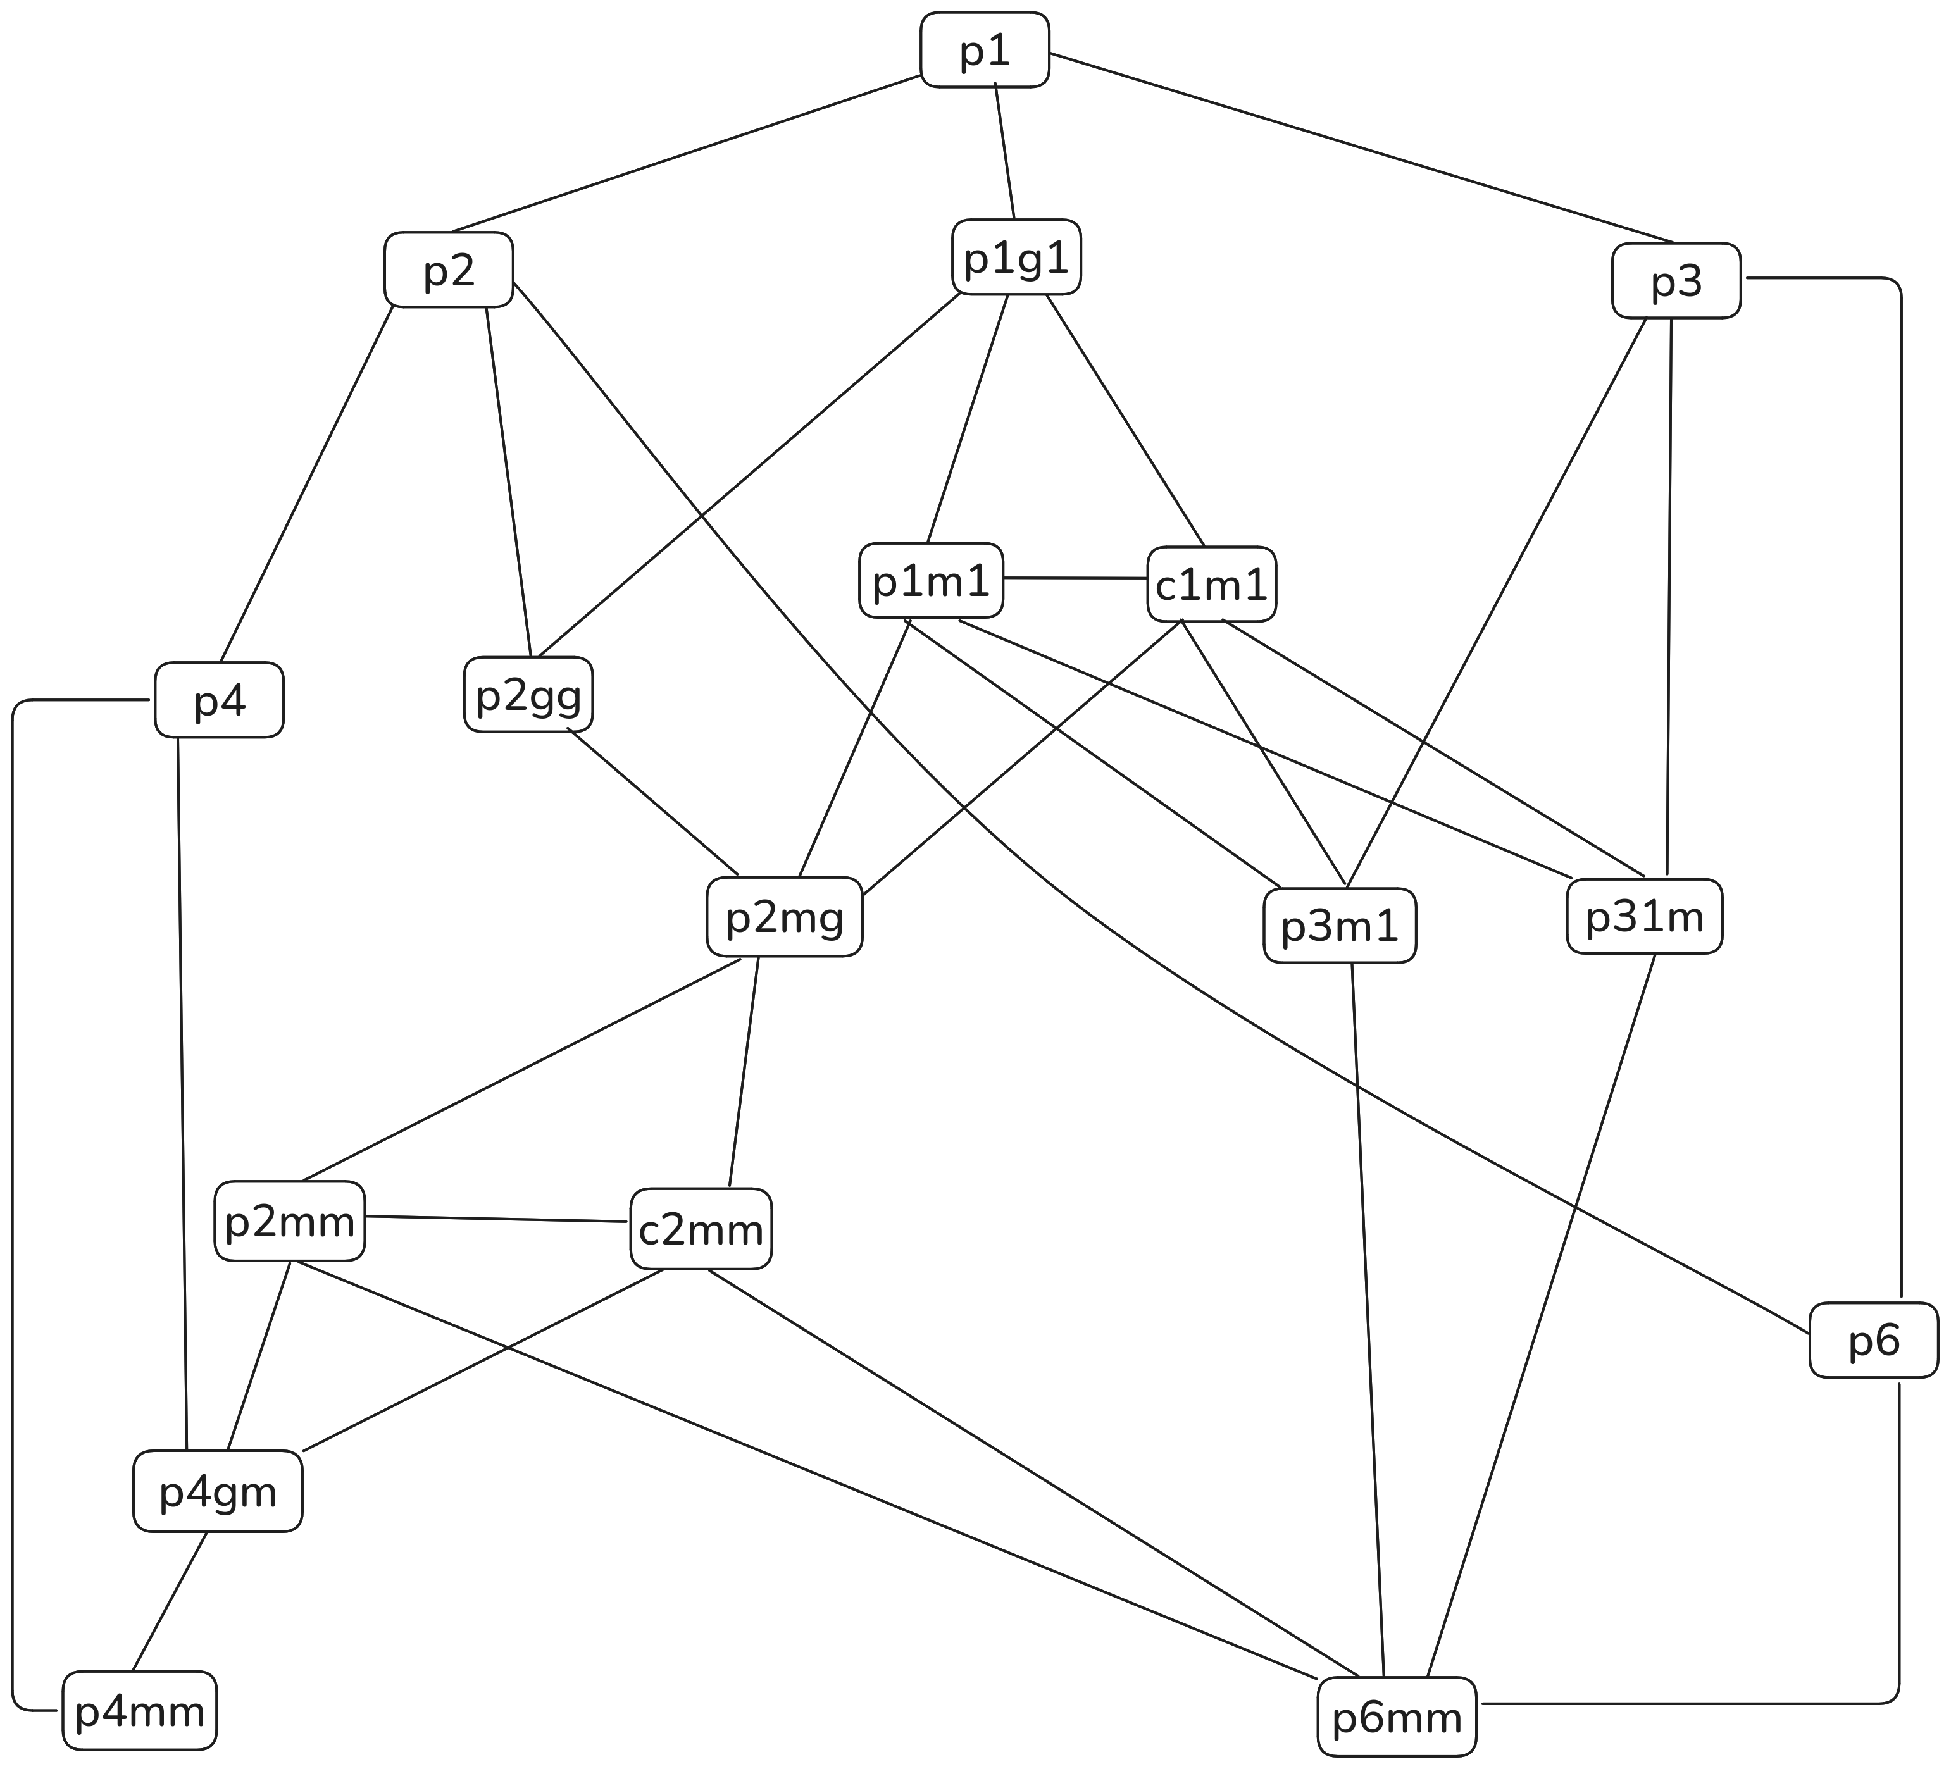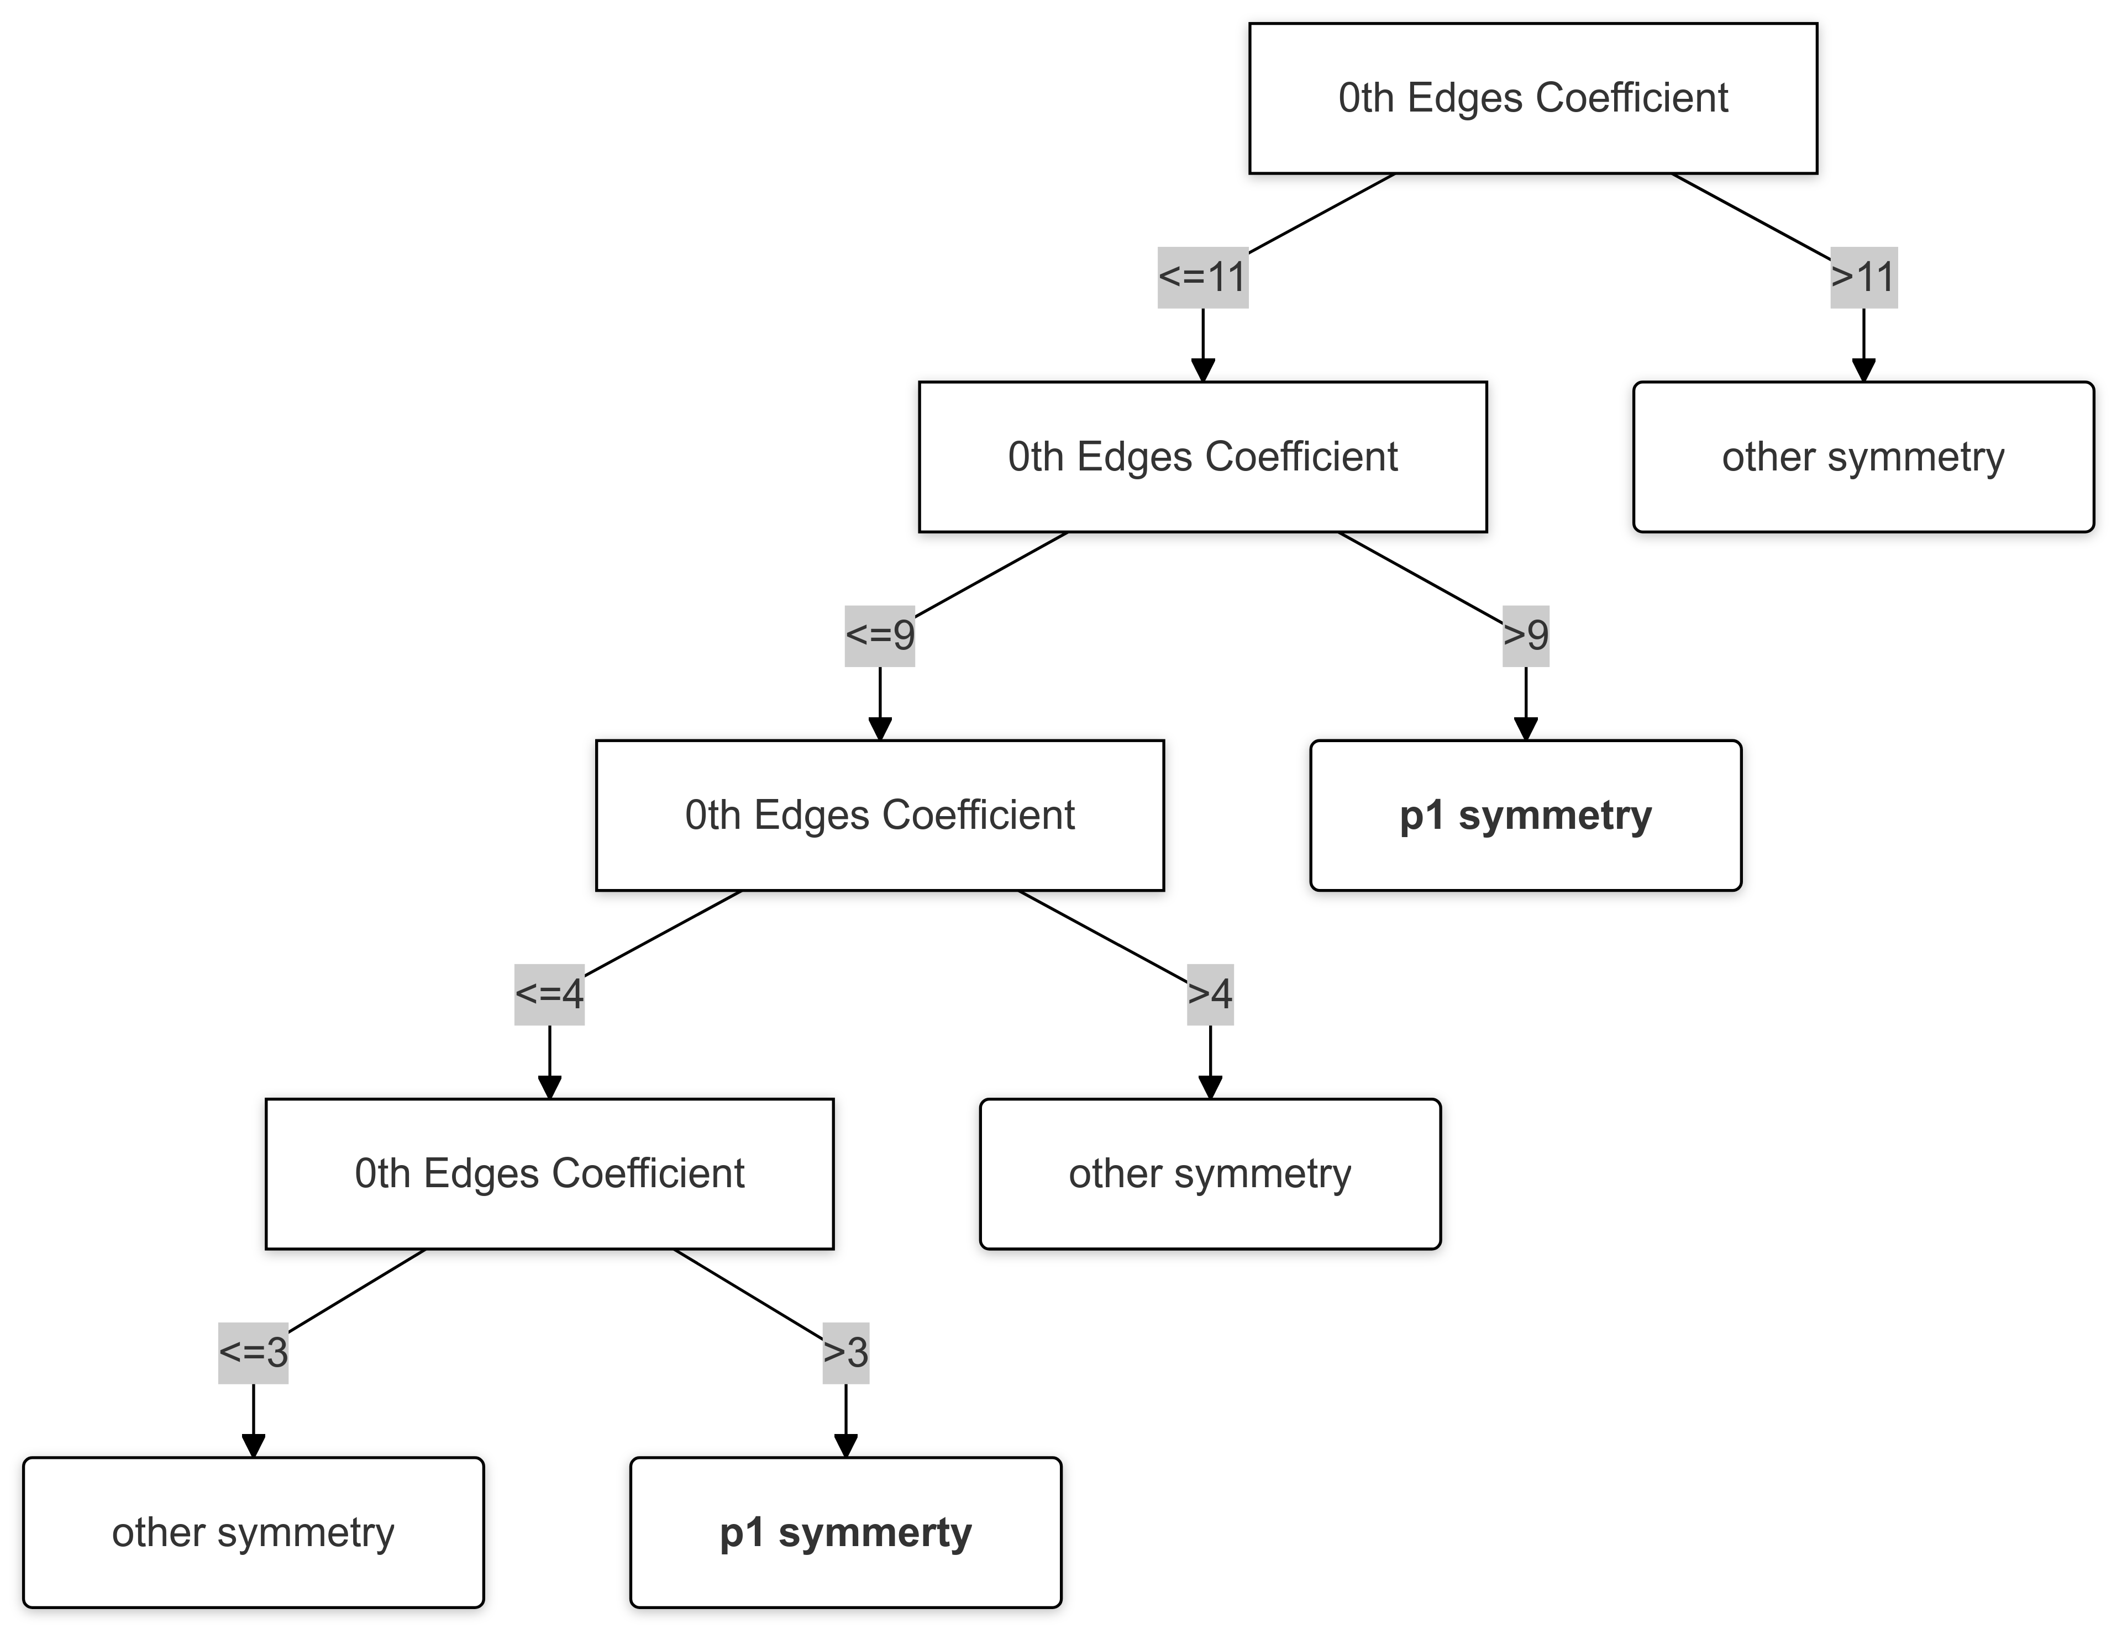

Growth functions in crystallography describe how the number of cells, edges, and vertices increases as a periodic tiling expands. For a tessellation with symmetry group G, the growth function fd(m,n) counts the number of d-dimensional cells when expanding m steps in one direction and n steps in another. These functions have the form: fd(m,n) = Cd0 mn + Cd1 m + Cd2 n + Cd3. The orphic diagram visualizes these functions, revealing deep connections between coefficients and symmetry properties. As demonstrated in [1] these diagrams provide a complete topological description of the tessellation. Using decision tree classifiers, feature engineering, and a hierarchical framework, we have developed a method to classify most of the 17 wallpaper symmetry groups based solely on growth function coefficients. Our approach exploits mathematical properties, particularly divisibility relationships between coefficients, to separate symmetry groups with perfect accuracy. The hierarchical classification begins with the most general group (p1) and progressively distinguishes groups with increasing symmetry complexity. By analyzing patterns in the coefficients, we identify rules that perfectly separate groups with different rotational, reflective, and glide symmetries. Our computations were done systematically with the help of the computer package [2] and recently improved to an efficient version implemented in Julia package.

[1] B. Naskręcki, J. Malinowski, Z. Dauter and M. Jaskólski. Growth functions of periodic space tessellations. Acta Crystallogr. A: Found. Adv., 81(1):64–81, 2025.

[2] J. Malinowski, Z. Dauter, B. Naskręcki. Orphic diagrams: Python package for computing growth functions of planar tessellations. Zenodo, 2022.

[3] B. Naskręcki, M. Jaskólski, and Z. Dauter. The Euler characteristic as a basis for teaching topology concepts to crystallographers. J. Appl. Crystallogr., 55(1):154–167, 2022.

[4] B. Naskręcki, Z. Dauter, and M. Jaskólski. A topological proof of the modified Euler characteristic based on the orbifold concept. Acta Crystallogr. A, 77(4):317–326, 2021.

[5] B. Naskręcki, Z. Dauter, and M. Jaskólski. Arithmetic proof of the multiplicity-weighted Euler characteristic for symmetrically arranged space-filling polyhedra. Acta Crystallogr. A, 77(2):126–129, 2021.