# Back to morphology: streamlined modelling of crystals' growth from solutions

## Y. Vaksler1*, F. Ngono Mebenga1, C. Xiouras1, P. Fernandes1

### 1Janssen Research and Development, Pharmaceutical and Material Sciences (PM&S),

### Janssen Pharmaceutical Companies of Johnson & Johnson, 2340 Beerse, Belgium

### * yvaksler@its.jnj.com

For a long time, modeling of crystal morphology was of low importance in production and lagged behind the experimental study due to several factors. Firstly, modeling of crystals’ morphology requires the availability of their already studied structures. Secondly, the brute force approach to find all of the existing faces involves obtaining attachment energies for a significant number of layers is quite slow. Calculations are therefore performed on a limited set of Miller indices and require averaging of the distribution of interaction energies over the layers ignoring their distribution. It makes crystals’ habits and Miller indices of faces the achievable goals instead of their morphologies and outlooks. Finally, the modeling of crystal growth from solutions with classical methods is rather stochastic in nature and requires large investments and significant user knowledge. We propose an approach that finally makes such simulations fast, simple and effective to a degree sufficient for their practical use.

Our research is based on the model MONTY in the CrystalGrower implementation [1-2]. This model considers crystal growth as a process of random sequential acts of attachment and detachment of individual molecules. The probabilities of such acts are calculated from the relative gain in energy due to the formation or destruction of sites, i.e. potential positions of molecules with a unique set of neighbors that are consistent with an experimental crystal structure or one obtained via CSP. These gains are calculated from sets of pairwise interaction energies (B97D3/cc-pVDZ) of the site molecule with its neighbors and do not require any cumbersome calculations:

|  |  |
| --- | --- |
| $$p_{s}^{attachment}=exp\left[-0.5\left(\frac{ΔU_{s}}{kT}\right)+0.5\left(\frac{Δμ}{kT}\right)\right]$$ | (1) |
| $$p_{s}^{detachment}=exp\left[0.5\left(\frac{ΔU_{s}}{kT}\right)-0.5\left(\frac{Δμ}{kT}\right)\right]$$ | (2) |

where $ΔU_{s}$ is the energy of site stabilization; $Δμ$– chemical (supersaturation / driving force) potential; k – Bolzman constant; T – absolute temperature.

Among the additions, a quantum-chemical approach using the solvation model based on density (SMD) is known [3], which is the first approximation for modeling crystal growth from solutions. However, the algorithm we created allows us to include the solvent in the calculation explicitly with as full accounting for pair interactions as the level of theory allows. In the case represented on a figure 1, it is the molecular dynamics modeling approach using OPLS2005 force field. In addition, the ways to include a partitioning of conformational changes and thermodynamic parameters (T, P) into individual pairs of molecules were developed by us. Now, the methodology to include the supersaturation and many-body interactions in the model in ways of nature is still in the scope, but the model already provides us with valuable information on morphology, habit and interactions distribution both in bulk and at the crystal surface:

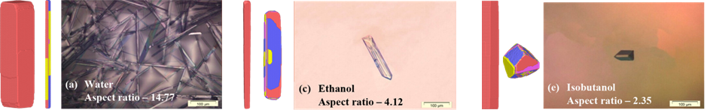

Figure 1. Theoretical crystal habits of urea with (in red) and without (in multi-color) our approach as well as the experimental habits obtained using cooling method from water, ethanol and isobutanol accordingly [4].

#### [1] Anderson, M.W., Gebbie-Rayet, J.T., Hill, A.R., Farida, N., Attfield, M.P., et al. (2017). *Nature.* **544**, 456.

#### [2] Hill, A.R., Cubillas, P., Gebbie-Rayet, J.T., Trueman, M., de Bruyn, N., et al. (2021). *Chem. Sci.* **12**, 1126.

#### [3] Spackman, P.R., Walisinghe, A.J., Anderson, M.W., Gale, J.D. (2023). *Chem. Sci.* **14**, 7192.

#### [4] Shahrir, N., Yusop, S.N., Anuar, N., Zaki, H.M., Tominaga, Y. (2023). *Cryst. Growth Des.* **23**, 4240.