Local structure studies using neutrons and X-rays augmented with theory

M. J. Gutmann¹, G. Lucian Pascut ², K. Wang³, B. Monserrat³, S.-W. Kim³, and M. Krzystyniak¹

¹Rutherford Appleton Laboratory, ISIS Facility, Chilton Didcot, Oxfordshire OX11 0QX, United Kingdom

²MANSID Research Center, University Stefan Cel Mare, 720229 Suceava, Romania

³Cavendish Laboratory University of Cambridge, Cambridge CB3 0HE, United Kingdom.

Email of communicating matthias.gutmann@stfc.ac.uk
RPdSb (R=La, Ce) are reported in space group P63/mmc with flat Pd/Sb layers. Our own single crystal studies show a puckering of the Pd/Sb layers [1]. This different structure leaves traces in the diffuse scattering. The revised crystal structure is supported by DFT in the case of La. For CePdSb DFT fails and the more advanced DFT + eDMFT is able to handle this compound. More recent work will be shown on KNiCl3, where we show that anharmonic phonon calculations are needed to explain this material. This compound shows a series of structural phase transitions accompanied by changes in the dielectric properties around room temperature as seen with both X-rays and neutrons. Diffuse scattering is present in all phases. Theory captures these phases. However, also in this case DFT + eDMFT gives a better geometry than DFT.
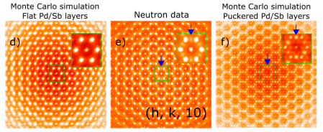

Figure 1. Diffuse neutron scattering in the (h,k,l0)-plane and model calculation for flat and puckered Pd/Sb layers with Bragg peaks omitted [1].

[1] M. J. Gutmann, G. L. Pascut, K. Katoh, M. v. Zimmermann, K. Refson and D. T. Adroja (2022), Materials 15, 7678.

