# Three refinement approaches to a description of a (3+1)D incommensurately modulated organic zwitterion dihydrate

**Ilia A. Guzei1, Kyana M. Sanders1, Václav Petříček2, Samantha Bruffy1, Andrew F. Buller1**

*1Chemistry Department, University of Wisconsin-Madison, 1101 University Ave., Madison, WI  53706, USA; 2Institute of Physics of the Czech Academy of Sciences, Na Slovance 2, 182 21 Praha 8, Czech Republic*

### [iguzei@chem.wisc.edu](mailto:iguzei@chem.wisc.edu)

Three structural refinements of the incommensurately modulated structure of (2S,3S)-2-amino-3-hydroxy-3-methyl-4-phenoxybutanoic acid (C11H15NO4·2H2O or **I**·2H2O) are presented: average approximation, commensurate supercell approximations, and the (3+1) superspace refinement. One of the water molecules of crystallization is disordered over two positions. The three approaches produce results of comparable precision and similar disorder ratio of the water molecule.

Whereas the satellite reflections are well observed, Fig.1, a single-crystal approximation that disregards them yields a high-quality structure in the space group *P*212121 with one water molecule refined as disordered over two positions in a 0.625:0.375(16) ratio. The absolute structure and absolute configuration are reliably established despite a low Friedif of 30.64.

The refinement in the commensurate three-fold supercell approximation in space group *P*1121 is also of high quality with the six corresponding water molecules exhibiting three different occupancy ratios averaging 0.635:0.365.

The structure of **I**·2H2O is correctly described in the (3+1)-dimensional superspace group *P*212121(0β0)000 (*β*=0.357). The loss of the three-dimensional periodicity is ascribed to the occupational modulation of the disordered solvent water molecule, with its two positions related by a small translation (ca. 0.666(9) Å) and ~168(5)° rotation about one of its O–H bonds, with an average 0.624(3):0.376(3) occupancy ratio. There is an extensive hydrogen-bonding networked formed by neutral and charge-assisted N–H…O and O–H…O interactions, and the water molecule’s occupational modulation arises due to the competition between the different hydrogen-bonding motifs associated with each position.

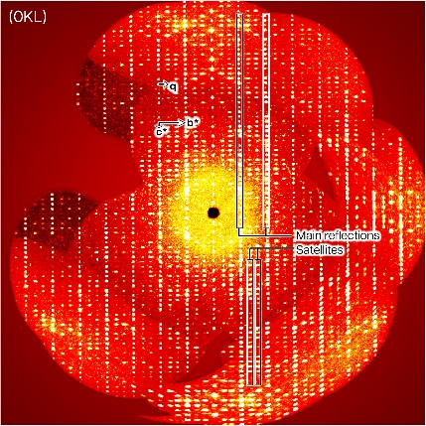

###### **Figure 1**. Annotated reconstruction of the *0kl* reciprocal space layer for the incommensurately modulated **I**·2H2O.