# Coupling X-ray diffuse scattering and spectroscopy to explore the local structure of hollandites

## M.Morana1, E. M. Schimdt2, G.O. Lepore1

### 1Department of Earth Sciences, University of Florence, Via G. La Pira 4, 50121, Firenze. Italy, 2Faculty of Geosciences, MARUM and MAPEX, University of Bremen, Klagenfurter Straße 2-4, 28359 Bremen, Germany

### marta.morana@unifi.it

Hollandite minerals comprise manganese and titanium tunnel oxides, which can be divided into two subgroups on the basis of the cation occupying the octahedral site: the coronadite group with Mn and the priderite group with Ti [1]. Their structures are made by double-chains of edge-sharing octahedra which form cavities usually hosting a large mono- or di-valent cation. The structural description of the hollandites is not straightforward and different distortion and disorder phenomena have been reported, such as symmetry lowering, cation displacement along the tunnels, and disorder of the octahedral cations. It is thus not surprising that diffuse scattering features were reported for some hollandite, both natural and synthetic. In fact, hollandite-type materials are widely studied for various applications comprising nuclear waste disposal and battery materials, requiring a deep understanding of local order to tune their physical properties. We characterized, by means of single crystal diffuse scattering and X-ray absorption spectroscopy (XAS), the local structure - including the interplay of channel cation ordering and framework distortions - of a natural hollandite (coronadite group) and a mannardite (priderite group). The diffuse scattering was interpreted by means of 3D-ΔPDF [2] and the obtained information, together with the results from XAS, were used to build a disordered model to perform a quantitative analysis. This approach allowed us to investigate the different source of disorder and highlights that interactions both along and between tunnels are actually present and contribute to diffuse scattering.

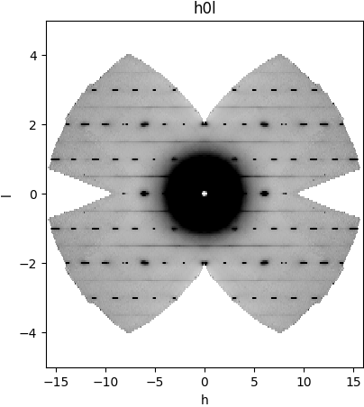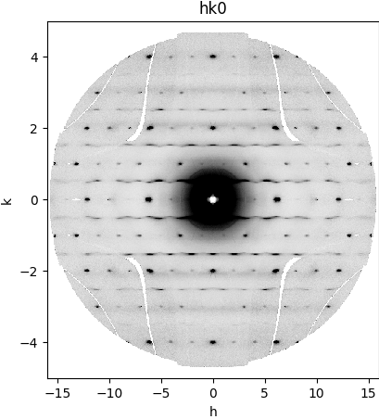

###### **Figure 1**. Symmetry averaged diffuse scattering data for hollandite (left) and mannardite (right)

#### [1] Margilies, L., Kramer, M. J., McCallum, R. W., Kycia, S., Haeffner, D. R., Lang, J. C. & Goldman, A. I. (1999). *Rev. Sci. Instrum.* **70**, 3554.

#### [2] Chupas, P. J., Ciraolo, M. F., Hanson, J. C. & Grey, C. P. (2001). *J. Am. Chem. Soc.*, **123**, 1694.

#### [3] Bunge, H. J. (1982). *Texture Analysis in Materials Science*. London: Butterworth.

#### [4] Balzar, D. & Popa, N. C. (2004). *Diffraction Analysis of the Microstructure of Materials*, edited by E. J. Mittemeijer & P. Scardi, pp. 125-145. Berlin: Springer.

G.O.L. acknowledges funding by the Ministero dell’Università e della Ricerca through the project PRIN 2020 “HYDROX – HYDRous- vs OXo-components in minerals: adding new pieces to the Earth’s H2O cycle puzzle”, prot. 2020WYL4NY. The authors acknowledge the ESRF and CERIC-ERIC for provision of beamtime for proposals 20217085/A08-1-1088 (CERIC-ERIC/ESRF; doi.org/10.15151/ESRF-ES-819990152) and ESRF ES-1256.