# Direct imaging of beam-sensitive inorganic materials using 2D and 4D scanning transmission electron microscopy

## P.D. Nellist1

### 1Department of Materials, University of Oxford, 16 Parks Road, Oxford, OX3 7TW, UK

### peter.nellist@materials.ox.ac.uk

The development and widespread application of aberration-corrected electron microscopy over the past 25 years has made atomic resolution imaging and spectroscopy of materials routine. Many candidate materials for important applications in energy conversion and energy storage are highly susceptible to damage under the irradiating electron beam and so an important current challenge is to develop methods that can allow the high-spatial resolution advantages of aberration correction to be applied to these materials.

Here, the use of the aberration-corrected scanning transmission electron microscope (AC-STEM) for such applications will be described. It will be shown that the dose fractionation in both space and time enable by AC-STEM enables atomic resolution images to be formed for materials that hitherto have eluded such imaging. This approach will be illustrated by an application to hybrid organic-inorganic perovskites for photovoltaics [1].

The development of fast pixelated detectors for the scanning transmission electron microscope (STEM) has allowed the recording of 4D-STEM data-set that comprises two dimensions in real space (the probe position) and two dimensions in reciprocal space (the position in the detector plane diffraction pattern). Many methods have been developed to make use of such data, including ptychography, centre of mass (first moment) and integrated centre of mass, which can each be related to phase imaging. Using imaging of a zeolite, it is shown that electron ptychogaphy can be performed at very low doses [2] and its use in a range of functional materials is demonstrated [3,4]. Finally, the use of imaging detective quantum efficiency as a method to compare ptychography in the STEM with conventional TEM methods will be discussed.

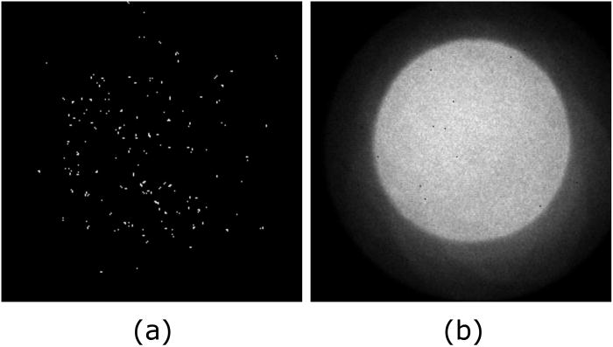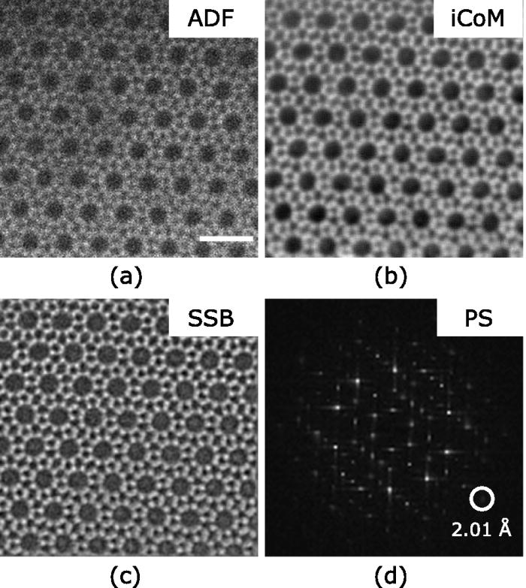

###### **Figure 1**. (a) An individual convergent beam electron diffraction pattern, containing ~100 electrons, from the 4D STEM data set recorded from Zeolite ZSM-5. (b) The reconstructed ptychographic image of ZSM-5. Experimental details can be found in Ref. [2].

#### [1] Uller Rothmann, M., Kim, J. S., Borchert, J., Lohmann, K. B., O’Leary C. M., Sheader, A. A., Clark, L., Snaith, H. J., Johnston, M. B., Nellist, P. D., Herz, L.M., (2020). *Science* **370**, eabb5940.

#### [2] O’Leary C. M., Allen, C. S., Huang, C., Kim, J. S., Liberti, E., Nellist, P. D., Kirkland, A. I. (2020) *Appl. Phys. Lett.* **116**, 124101.

[3] Song, W., Pérez-Osorio, M. A., Marie, J.-J., Liberti, E., Luo, X., O’Leary C. M., House, R. A., Bruce, P. G., Nellist, P. D. (2022) *Joule* **6**, P1049.

[4] Song, W., Pérez-Osorio, M. A., Chen, J., Ding, Z., Marie, J.-J., Juelsholt, M., House, R. A., Bruce, P. G., Nellist, P. D. (2024) *J. Am. Chem. Soc* **146**, 23814.