# Structural description, Correction to the formula and thermal analysis of heterobimetallic coordination polymer based on phthalic acid

## A. Benkanoun1,2, H. Kherfi1,2, F. Balegroune2

### 1Ecole Nationale Supérieure des Technologies Avancées, 474 Place des martyrs, Algiers, Algeria

### 2Laboratoire de Cristallographie-Thermodynamique, Faculté de Chimie, USTHB, BP32 EL Alia, Bab Ezzouar, Algiers, Algeria

### Email of communicating abenkanoun@gmail.com

The self-assembly of fascinating coordination polymers (CPs) remains a topical research subject. Materials of interest in terms of applications in several fields, environment, storage, gas separation, catalysis, optoelectronics, etc [1-2]. They result from multifunctional organic ligands combined with metals by coordination bonds, sometimes associated to supramolecular interactions.

The title heterobimetallic complex has been synthesized from aqueous solution of a mixture of H2BDC acid, barium and copper salts. Biagini Cingi *et al* have previously reported a basic description of the structure [3]. In this previous study, they speak of a complex with four water molecules of different nature. Our study allowed a new refinement with significant better precision with all H atoms positions. The asymmetric unit consists of one Ba(II) cation, one Cu(II) cation, two o-phthalate dianions and four water molecules In fact. The new formula [BaCu(OOC-C6H4-COO)2(H2O)4] highlights the four coordination water molecules, major difference noted. This result is confirmed by TGA/DTA. The dehydration occurs from 105°C to 180 °C with the departure of the four coordination water molecules; the experimental value of 11.44 % is in agreement with the theoretical percentage of 11.97 %.

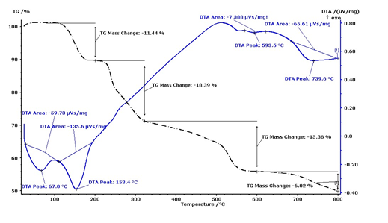

**Figure 1**. TGA/TDA curve of [BaCu(OOC-C6H4-COO)2(H2O)4]

[1] Zhang,Q., Zhou, Z., Wang, X., Lu, J. (2016) *Chem. Res. Chin. Univ*., **32**, 165.

#### [2] Roy, I., Brandão, P., Majumder, A., Bera, M., Banerjee, S. (2024) *J. of Mol. Struct*., **1317**, 139085.

#### [3] Biagini Cingi, M., Manotti Lanfredi, A. M., Tiripicchio, A., Tiripicchio Camellini, M. (1978) Acta Cryst., **B34**, 774.