# Crystal structure and hydrogenation properties of the MgNi2B6 ternary compound

## N. Pavlyuk1, A. Bondaruk2, D.Kulawik2, W.Ciesielski2, V. Pavlyuk1,2

### 1Department of Inorganic Chemistry, Ivan Franko National University of Lviv, Kyryla & Mefodia str. 6, 79005 Lviv, Ukraine,

### 2Jan Długosz University in Częstochowa, Institute of Chemistry, al. Armii Krajowej 13/15, 42200 Częstochowa, Poland

### Email of communicating v.pavlyuk@ujd.edu.pl

The intermetallic compounds based on magnesium are widely investigated now due to their excellent hydrogen storage and electrochemical properties [1]. During the systematic study of Mg–Ni-B alloys, the tetragonal phase MgNi2B6 was detected. The MgNi2B6 ternary compound was prepared in a tantalum crucible in a resistance furnace with a thermocouple controller. The single crystal of MgNi2B6 was investigated by means of an Oxford Diffraction Xcalibur3 diffractometer with a CCD detector. The crystal structure of the MgNi2B6 compound was successfully solved by direct methods and refined in the space group *Immm* (N◦71). The refined lattice parameters are *a=*3.0985(8) Å, *b*=6.5572(13) Å, *c*=8.3176(17) Å, *V*=168.99(6) Å3. The starting atomic parameters were taken from an automatic interpretation of direct methods followed by difference Fourier syntheses using the SHELX-97 package programs [2]. Finally, all parameters are refined to *R*1 = 0.047 and *wR*2 = 0.122 using 129 independent reflections with I > 2σ(I) and presented in Table 1. The ternary boride MgNi2B6 is isostructural to CeCr2B6 [3]. Boron nets are presented in Figure 1.

The prepared MgNi2B6 sample was hydrogenated by hydrogen gas at a pressure up to 20 bar and a temperature of 623 K. Under these conditions, MgNi2B6 absorbs up to 2.4 wt% H2.

**Table 1**. Fractional atomic coordinates and equivalent isotropic displacement parameters (Å2) for MgNi2B6

|  |  |  |  |  |  |
| --- | --- | --- | --- | --- | --- |
| Atoms | Sites | *x* | *y* | *z* | *U*eq |
| B1 | 4*h* | 0 | 0.139(3) | 1/2 | 0.041(3) |
| B2 | 8*l* | 0 | 0.290(1) | 0.332(1) | 0.034(2) |
| Ni | 4*j* | 1/2 | 0 | 0.3484(3) | 0.0492(7) |
| Mg | 2*a* | 0 | 0 | 0 | 0.035(1) |

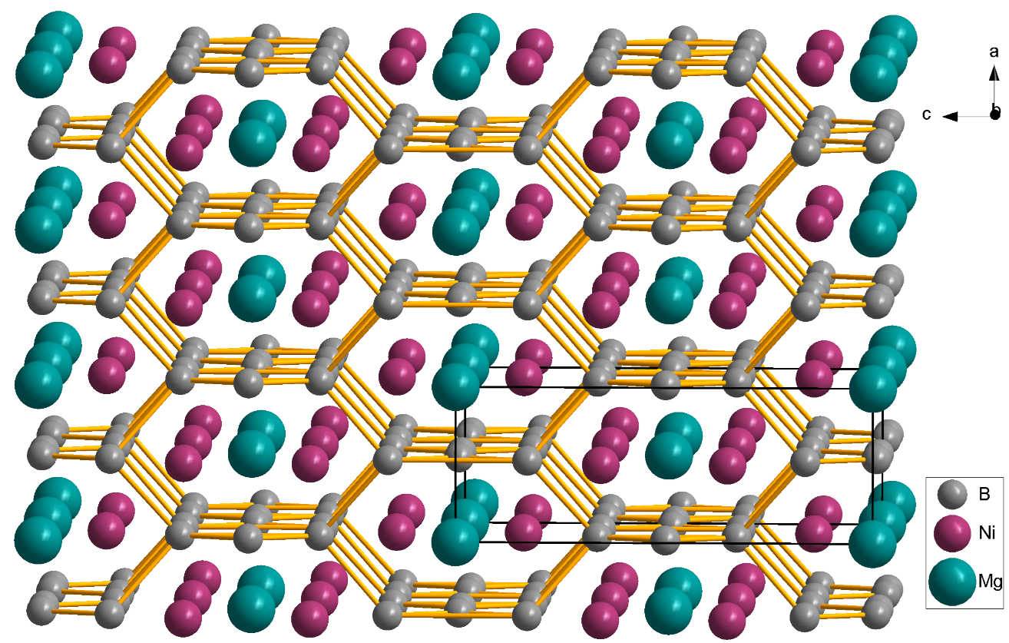

**Figure 1.** Boron nets in the MgNi2B6 structure

[1] Larpruenrudee, P., Bennett, N. S., Gu, Y., Fitch, R., & Islam, M. S. (2022). *Scientific Reports*, **12**(1), 13436.

[2] Sheldrick, G. M. (1997). *SHELXL97*. University of Gӧttingen,Germany.

[3] Kuz'ma Y.B., Svarichevskaya S.I., Fomenko V.N. *Inorg. Mater.* (1973) **9**, 1372-1374.