# X-ray Absorption Spectroscopy implementation on a laboratory X-ray powder diffractometer

## M. Gateshki, Ch. Zarkadas, G. Nénert, L. Ding, D. Beckers, H. Hussain

### Malvern Panalytical B.V. Lelyweg 1, 7602 EA, Almelo, The Netherlands

### milen.gateshki@malvernpanalytical.com

X-ray Absorption Spectroscopy (XAS) is a powerful technique for analysing the structure and properties of new materials [1,2]. It examines how the absorption coefficient behaves near the absorption edge of a specific element, providing valuable insights into the oxidation state, electronic structure and short-range ordering (interatomic distances and coordination numbers). XAS complements X-ray Diffraction (XRD) and is especially useful for relatively complex materials where traditional techniques that rely on crystallographic order are not applicable, such as liquids and amorphous substances. Compared to the Pair Distribution Function (PDF) method - which also probes short-range ordering in materials, including amorphous phases and liquids, but provides averaged data across all atomic species - XAS is element-specific. This allows it to distinguish between the environments of atoms with similar atomic numbers, such as two types of metal atoms in an alloy or solid solution. Usually, XAS data are collected at synchrotron beamlines or using dedicated laboratory instruments. In this contribution, we propose a novel experimental setup that enables the acquisition of high-quality XAS data in transmission mode using a standard laboratory-based diffractometer. The configuration utilises standard components commonly available in modern diffractometers, such as X-ray tubes with enhanced stability, accurate goniometers and position-sensitive photon-counting detectors with improved energy resolution. This approach may broaden the use of XAS in materials research, especially among users already employing diffraction methods. The method has been used to analyse successfully the K absorption edges of many different compounds with elements ranging from Ti to Mo and L edges of elements like Pt an Au. Fig. 1(a) shows the XAS spectra of α-Fe2O3 (hematite) and Fe3O4 (magnetite) powders, compared with a reference spectrum of a 7.5 µm thick Fe foil. Each scan was completed in one hour. Clear differences in the position and shape of the Fe absorption edge are observed, indicating the distinct oxidation states and atomic coordination environment in the three samples. Pre-edge features are also visible in the oxide samples. The results are consistent with previous synchrotron-based studies, such as that reported in [3]. The EXAFS signal of the Fe foil measured with the laboratory set-up is shown in Fig. 1(b) and is compared with a reference synchrotron measurement [4].

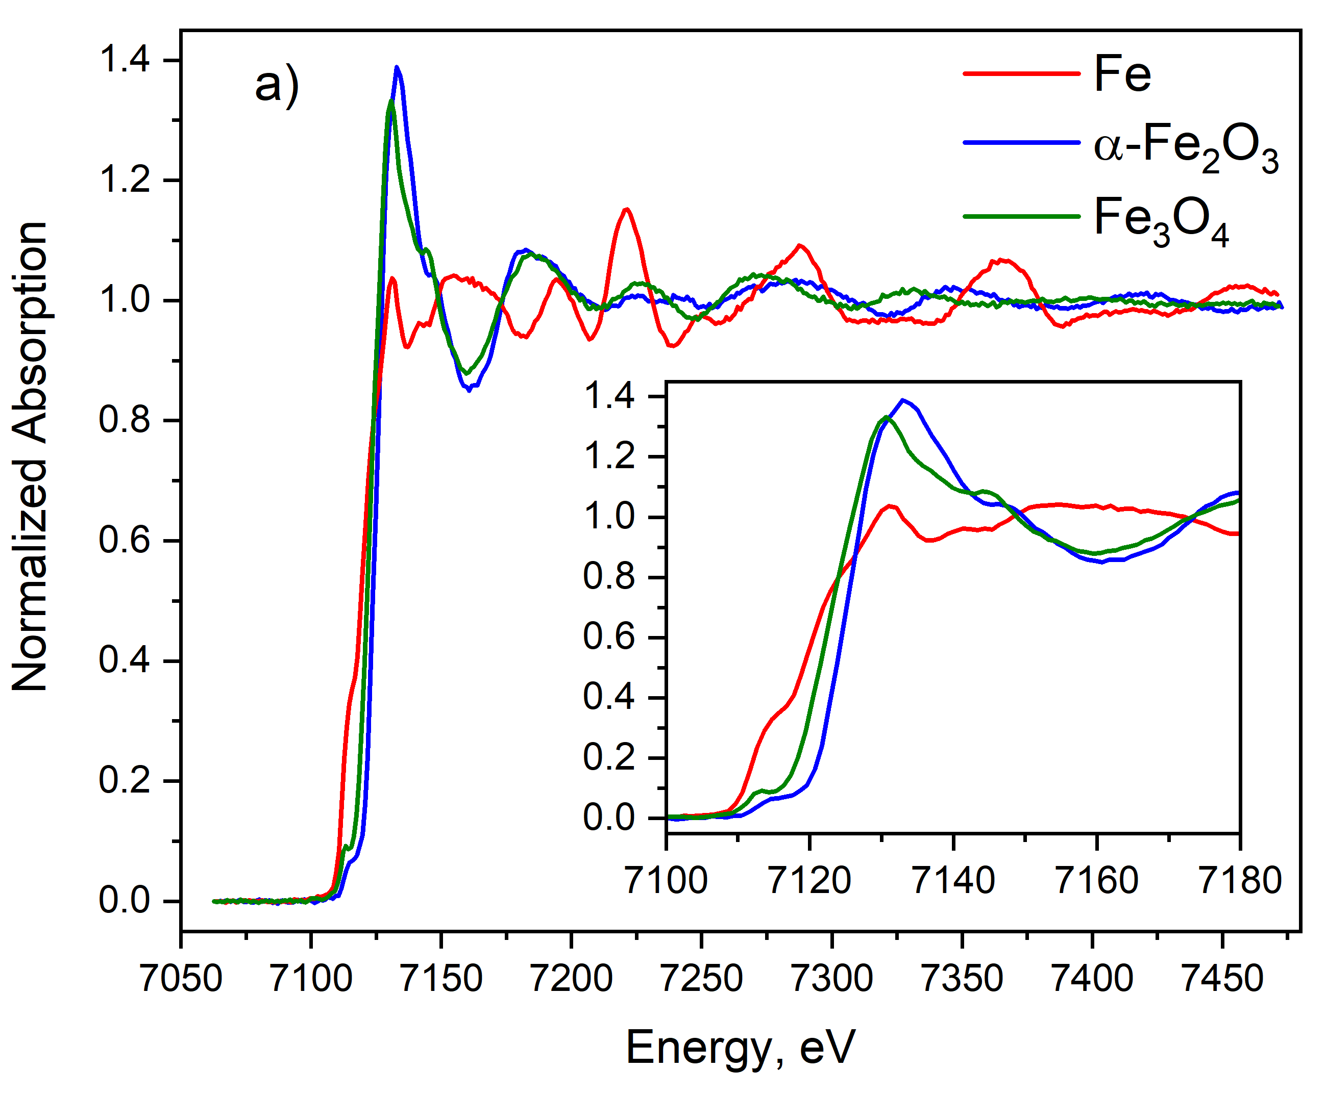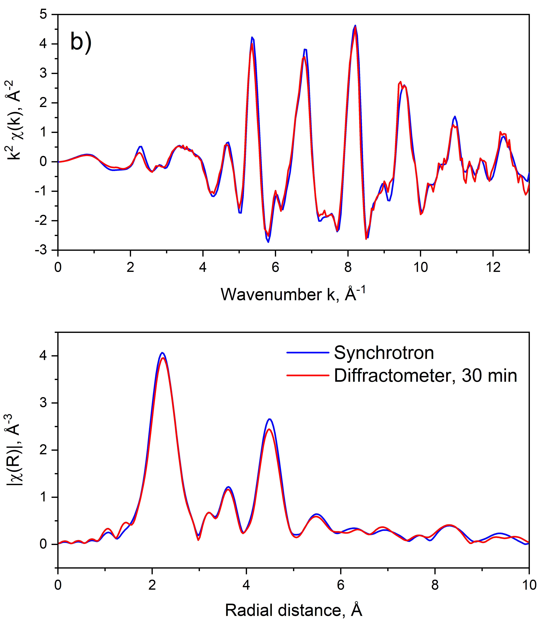

###### **Figure 1**. a) XAS spectra of α-Fe2O3 (blue) and Fe3O4 (green) powder samples, compared with the corresponding spectrum of a 7.5 µm Fe reference foil (red). The inset shows a magnified view of the XANES range. b) EXAFS signal and the corresponding Fourier transform of Fe compared with the result of a synchrotron measurement adjusted to the same k range (blue).

[1] Zimmermann, P., Peredkov, S., Abdala, P. M., DeBeer, S., Tromp, M., Müller, C. & van Bokhoven, J. A. (2020). *Coord. Chem. Rev*. 423, 213466.

[2] Cutsail, III, G. E. & DeBeer, S. (2022). *ACS Catal*. 12, 5864–5886.

[3] Xiao, X., Ruan, Z., Li, Q., Zhang, L., Meng, H., Zhang, Q., Bao, H., Jiang, B., Zhou, J., Guo, C., Wang, X. & Fu, H. (2022). *Advanced Materials*, 34(27), 2200612.

[4] Materials Data Repository, XAFS spectrum of Iron. https://doi.org/10.48505/nims.3903