# From Structure to Solubility: Crystal Surface Insights into Pharmaceutical Cocrystals

## E. Zmeškalová1,2, F. Stara¹, T. Havlůjová¹, M. Šooš¹

### ¹Department of Chemical Engineering, University of Chemistry and Technology Prague, Technická 3, 166 28 Prague 6, Czechia

### ²Department of Structure Analysis, Institute of Physics of the Czech Academy of Sciences, Cukrovarnická 112/10, 162 00 Praha 6, Czechia

### Email of communicating author: eliska.zmeskalova@vscht.cz

Understanding and controlling solid-state properties of pharmaceutical ingredients is essential for ensuring manufacturability and bioavailability. We present an integrated experimental-computational approach that combines single-crystal X-ray diffraction with particle-based computational modelling to rationalize the impact of crystal structure on dissolution behaviour. As a model system, we studied cannabigerol (CBG), a non-psychotropic cannabinoid with pharmaceutical potential but suboptimal physicochemical properties. Cocrystallization with piperazine and tetramethylpyrazine yielded two novel multicomponent solids with enhanced melting points and modified morphology. [1]  
  
While both cocrystals improved thermal properties, only the tetramethylpyrazine cocrystal exhibited a significant increase in dissolution rate. To understand this divergence, we employed the CSD-Particle suite to analyze predicted crystal morphologies, surface topologies and intermolecular interaction patterns. [2-4] Key descriptors, such as electrostatic charge distribution and full interaction maps for water probe (Fig. 1), showed strong correlation with intrinsic dissolution rate. Specifically, the presence of polar functional groups and unsatisfied hydrogen-bond donors on major crystal facets were found to enhance wettability and promote faster dissolution.  
  
Our results highlight the utility of combining crystallographic data with surface-specific descriptors to predict and optimize biopharmaceutical performance. This approach contributes to the evolving paradigm of digital design in pharmaceutical development, where computational tools guide solid form selection and property engineering based on structural insight.

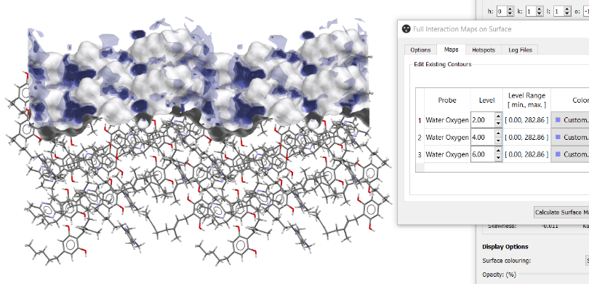

###### **Figure 1**. Full interaction map on the surface for water probe

#### [1] Zmeskalova, E., Stara, F., Havlujova, T. & Soos, M.. IUCrJ **2025**, 12, 141-154.

#### [2] Moldovan, A. A.; Maloney, A. G. P. *Crystal Growth & Design* **2024**, *24* (10),

#### [3] Kopczyńska, K.; Kingsbury, C. J.; Pidcock, E.; Moldovan, A. A.; Madura, I. D. *Crystal Growth & Design* **2024**, *24* (12), 5159–5170.

[4] Prandini, E.; Calì, E.; Maloney, A. G. P.; Parisi, E.; Simone, E. *Powder Technology* **2024**, *443*, 119927.