# Unexpected Shielding Effect of the BF4- Counter Ions in the X-ray Absorption Spectrum in Crystals of a FeII Metallogrid Complex.

## J. J. Velazquez-Garcia1*, S. S. Nair Lalithambika1, S. A. Salem1, E. Otero2, J. Wong3, S. Demeshko3, F. Meyer3, S. Kulkarni4, S. Techert1,5

### 1 Deutsches Elektronen-Synchrotron DESY, Notkestr. 85, 22607 Hamburg, Germany,2 Synchrotron Soleil, Saint Aubin BP48, 91192 Gif sur Yvette Cedex, France, 3Institut für Anorganische Chemie, Georg-August-Universität Göttingen, Göttingen, 37077, Germany, 4Centre for X-ray and Nano Science CXNS, Deutsches Elektronen-Synchrotron DESY, Notkestr. 85, 22607 Hamburg, Germany 5Institut für Röntgenphysik, Georg-August-Universität Göttingen, Göttingen, 37077, Germany.

### jose.velazquez@desy.de

Over the past few year, we have investigated the light- and temperature-induced structural changes in three oligonuclear spin crossover (SCO) complexes with grid-like arrangements. These compounds include the tetranuclear metallogrid [FeII4LMe4](BF4)4·2MeCN (**FE4Me**·MeCN), the trinuclear [FeII3LH2(HLH)2](BF4)4·4MeCN (**FE3H**·MeCN) and the grid-like dimer [FeII(HL)2]2(BF4)4·2MeCN (**FE2H**·MeCN), where LR =R-3,5-bis{6-(2,2′-bipyridyl)}pyrazole, R= H or methyl [1-4]. Through our studies, we identify a method to desolvate **FE4Me**·MeCN and **FE2H**·MeCN while preserving their crystallinity. During the exploration of the thermal spin crossover of the solvent-free **FE4Me** using variable temperature single crystal X-ray diffraction (VTSCXRD) at 20KeV, we observed Hard X-ray Induced Excited Spin State Trapping (HAXIESST) at temperatures below 120K [5]. Further attempts to study the XIESST phenomenon using X-ray Absorption Spectroscopy (XAS) with soft X-rays were unsuccessful, as the tail of the fluorine spectra cover the signal of the FeII ions sample (Fig. 1 left), making it barely visible. In contrast, XAS analysis of the crystalline **FE2H** and the powder **FE3H** reveals strong signals corresponding to the L-edge absorption of FeII. Moreover, XAS measurements of thin films from all samples, including **FE4Me**, exhibit prominent peaks associated with the L-edge absorption of FeII. SCXRD data collected on a **FE4Me** crystal, from the same batch used in the XAS experiments, confirmed the presence of FeII in the sample (Fig. 1 centre). The FeII is also observed in the crystallographic data of one crystal of **FE4Me**, out of many, taken after the XAS measurements from the sample holder. SEM/EDX analysis [6] of all crystalline samples further corroborate the presence of iron, consistent with the SCXRD findings (Fig. 1 right). The current results suggest that the shielding of the FeII spectrum by the fluorine may be related to the crystalline structure of the sample. However, the origin of this effects remains unknown, and further studies in the compound and similar metal complexes are needed to uncover this mystery that to our knowledge it is not reported yet in literature.

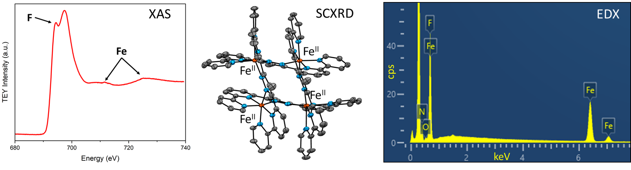

###### **Figure 1**. XAS spectrum (left), structural model of the cation (centre) and EDX spectrum (right) of **FE4Me**.

[1] Velazquez-Garcia, J. de J., Basuroy, K., Storozhuk, D., Wong, J., Demeshko, S., Meyer, F., Henning, R. & Techert, S. (2022). *Dalton Trans.* **51**, 6036–6045.

[2] Velazquez-Garcia, J. de J., Basuroy, K., Storozhuk, D., Wong, J., Demeshko, S., Meyer, F., Henning, R. & Techert, S. (2022). *Dalton Trans.* **51**, 17558–17566.

[3] Velazquez-Garcia, J. de J., Basuroy, K., Storozhuk, D., Wong, J., Demeshko, S., Meyer, F., Henning, R. & Techert, S. (2023). *Dalton Trans.* **52**, 12224–12234.

[4] Velazquez-Garcia, J. de J., Basuroy, K., Wong, J., Demeshko, S., Meyer, F., Kim, I., Henning, R., Staechelin, Y. U., Lange, H. & Techert, S. (2024). *Chem. Sci.* **15**, 13531–13540.

[5] Velazquez-Garcia, J. D. J., Basuroy, K., Storozhuk, D., Wong, J., Demeshko, S., Meyer, F. & Techert, S. (2022). *Acta Crystallogr., Sect. A* **78**, e694.

[6] Stierle, A., Keller, T. F., Noei, H., Vonk, V. & Roehlsberger, R. (2016). *JLSRF* **2**, A76–A76.