Crystal symmetry and magnetic structures in frustrated and non-frustrated Ho systems

M. S. Henriques,¹ S. Goswami,¹ V. Petříček,¹

¹FZU - Institute of Physics of the Czech Academy of Sciences, Prague, Czechia

henriques@fzu.cz
The question of what magnetic structure is realized in a crystal containing magnetic ions in the unit cell is in the center of many current problems in fundamental and applied modern physics. The role of crystal symmetry was long ago found paramount to solve this conundrum: the densities of the atomic magnetic moments will have arrangements compatible with the symmetry properties of the crystal under transformation keeping the energy invariant [1-4]. Current state-of-the-art in analysis and description of magnetic structures is the use of magnetic symmetry [5,6]. This approach is simple, unambiguous and robust, specifying the symmetry retained for all atoms (magnetic and not) and the magnetic symmetry broken during the transformation.
The relationship between the crystal and magnetic structures of some Ho-based compounds will be discussed in terms of magnetic symmetry approach and the respective broken and/or unbroken symmetries that explain the key properties of the materials. For example, the evolution of the magnetic incommensurate modulations in the layered Ho₃Co compound [7] is explained by a minimal symmetry-breaking from the paramagnetic to the antiferromagnetically ordered state. Two irreducible representations are active under the Pnm′a(α00)000 magnetic superspace group, which allows a dynamic evolution of the magnetic structure with no further symmetry breaking. The onset of the low-temperature magnetic phase of HoB₄ is accompanied by a monoclinic distortion coupled to ferroquadrupolar ordering of the Ho moments. This distortion, stabilizing the two-component magnetic structure, is a nonmagnetic order parameter carried under the magnetic space group P2₁/c’ that satisfies the energy invariance with the magnetic and quadrupolar orders [8]. The magnetic structure of Ho₃Ru₄Al₁₂ is described by a monoclinic magnetic (3+2)-superspace group. It can be explained as a long period longitudinal amplitude modulated spin wave propagating along the easy-axis and an in-plane transverse oblique spin wave. The symmetry breaking splits of the Ho position into two different orbits with different degrees of freedom. Nevertheless, to satisfy the nearest-neighbour interaction in the distorted kagome lattice, the spins remain coupled. One of the consequences is that the Ho ‘trimer’ acts as a unit along the modulation.

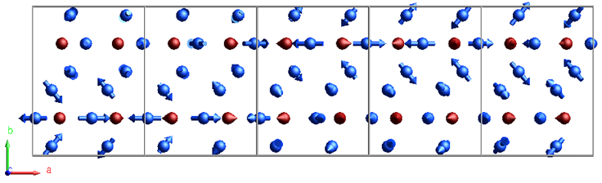

Figure 1. Spin modulation of Ho₃Co at 18 K for Ho (blue) and Co (red) represented in a 5×1×1 supercell of the parent orthorhombic unit cell. The modulation of Ho1 and Ho2 is described as fanlike, with a fan spanning of 100°. The modulation of the Co spins is a circular cycloidal restricted to be parallel to (101).

[1] S. Alexander, Phys. Rev. 127 (1962) 420. [2] N.V. Belov, N.N. Neronova, & T.S. Smirnova, Kristallografiya 2 (1957) 315. [3] E.F. Bertaut, et al., Solid State Commun. 5 (1967) 293. [4] W. Opechowski, Magnetism, Ed. G.T. Rado and H. Suhl, Vol. I1 A, Academic Press, New York 1965. [5] V. Petříček, J. Fuksa, & M. Dušek, Acta Cryst. A66 (2010) 649. [6] J. M. Perez-Mato, et al., Acta Cryst. B80 (2024) 219. [7] S. Goswami, et al., Phys. Rev. B 109 (2024) 214417.[8] D. Gorbunov et al., in preparation.

This work was co-funded by the European Union and the Czech Ministry of Education, Youth and Sports (Project TERAFIT, CZ.02.01.01/00/22_008/0004594).

